Model Guidance on

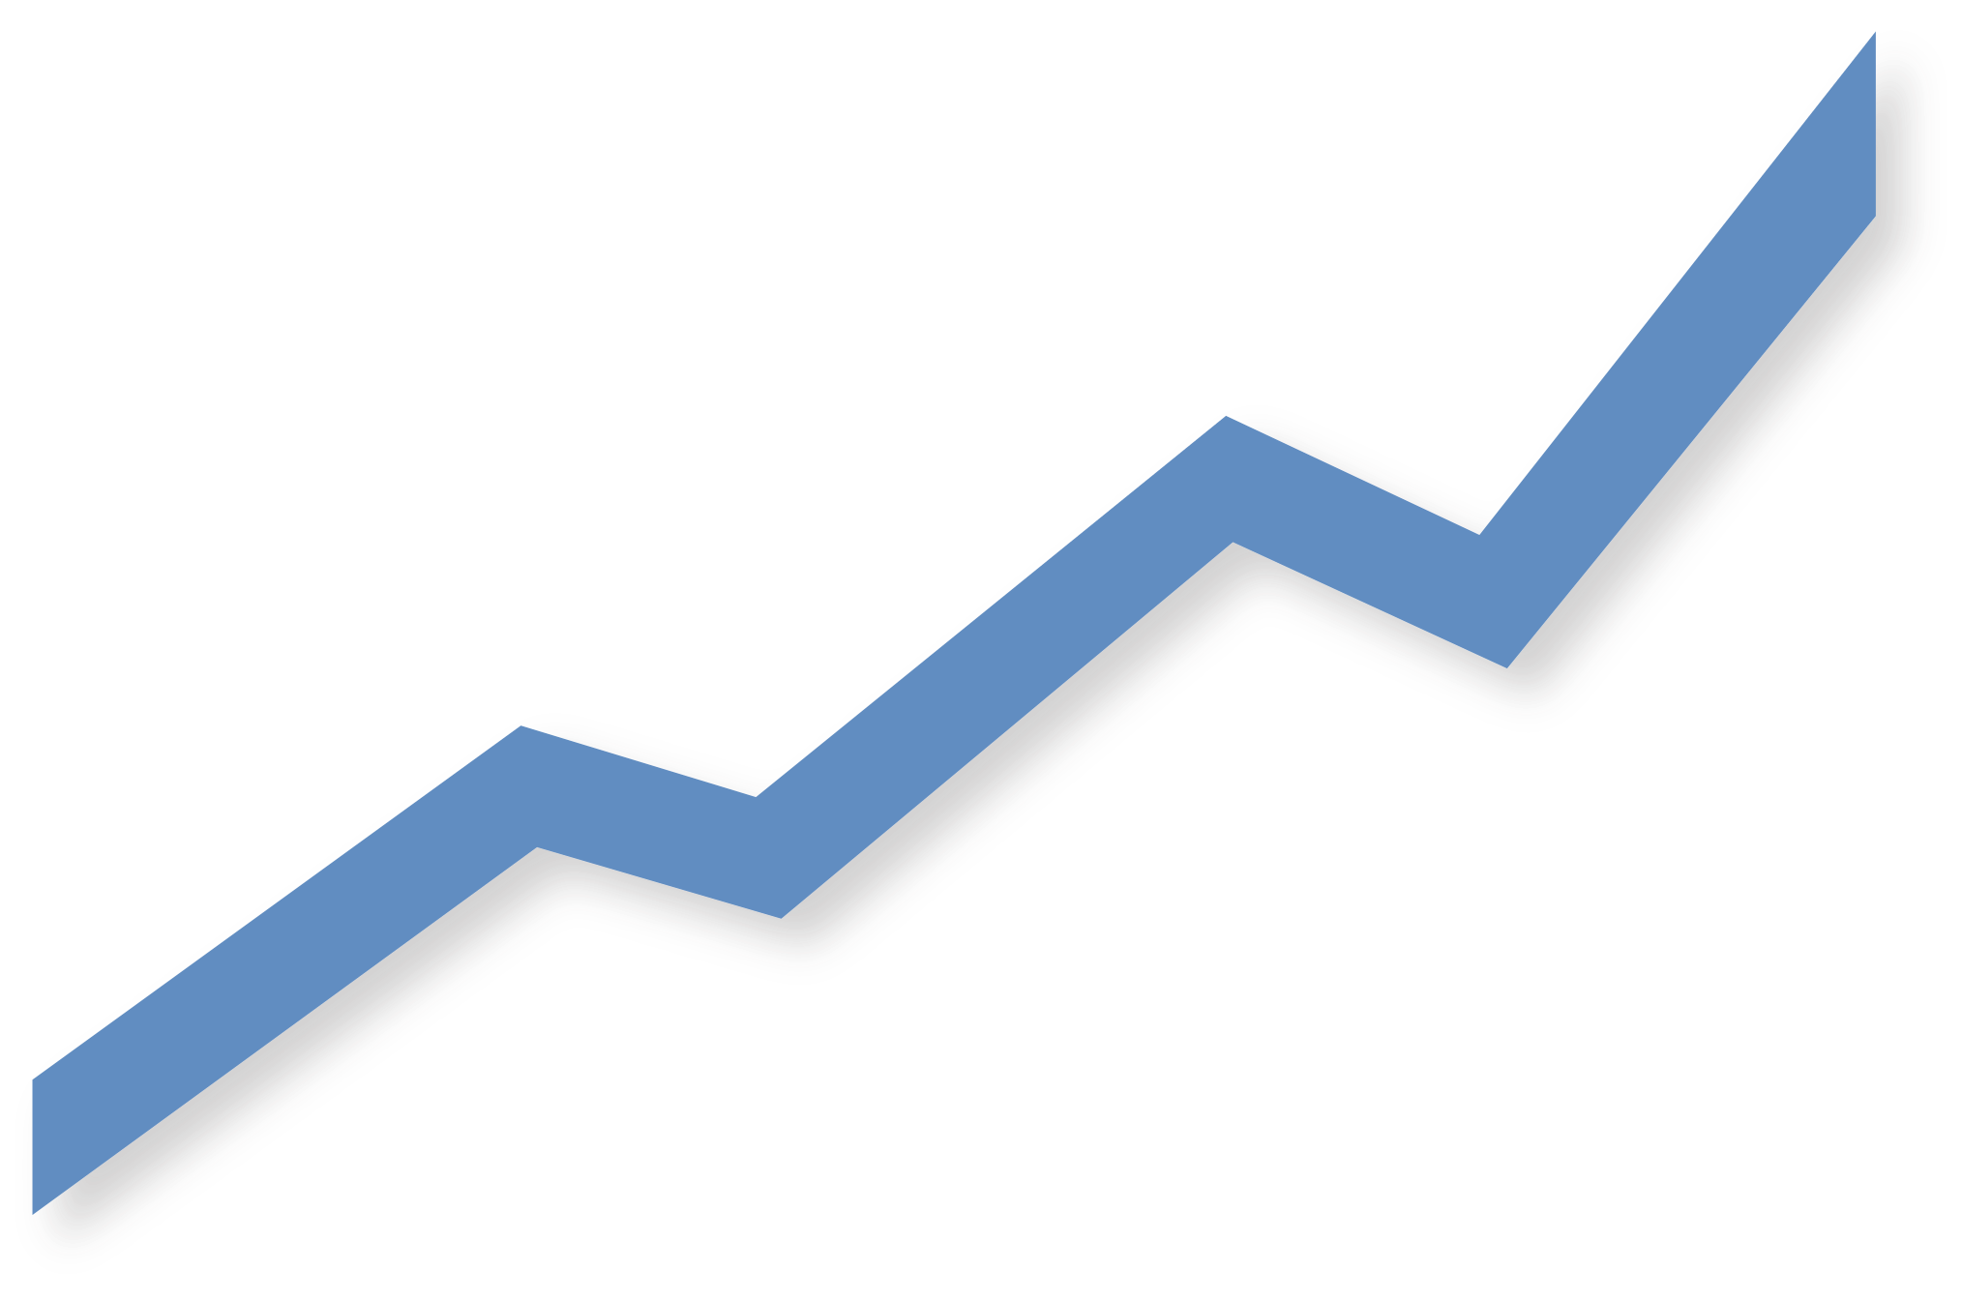
Sustainability-Related

Financial Disclosures
A template for stock exchanges
Version 2024.A

Acknowledgements  This paper was prepared in the context of the United Nations Sustainable Stock Exchanges (SSE). The paper was prepared by Tiffany Grabski (SSE Academy Head) and Mike Zimonyi (SSE Senior Specialist) under the overall supervision of Anthony Miller (SSE Chief Coordinator) and James Zhan (UNCTAD Director of Investment and Enterprise and Chair of the SSE Governing Board).  A special thanks is extended to the IFRS Foundation for providing technical and drafting assistance. Lois Guthrie (IFRS Foundation) played a crucial role in conducting research and drafting the text. The report benefited greatly from the feedback and advice of IFRS Foundation staff members Jonathan Bravo, Jarlath Molloy, Anoosha Lalani and Mardi McBrien. The SSE appreciates the contributions and thought leadership provided by the ISSB board members Jingdong Hua and Sue Lloyd. Additional research support and inputs were provided by Vanina Vegezzi (SSE Project Officer) and Corli Le Roux (SSE Senior Specialist).  The SSE gratefully acknowledges the financial support for the production of this report provided by Bloomberg Philanthropies and the International Finance Corporation.  About UN SSE  The SSE initiative is a UN Partnership Programme organized by UNCTAD, the UN Global Compact, UNEP FI and the PRI. The SSE’s mission is to provide a global platform for exploring how exchanges, in collaboration with investors, companies (issuers), regulators, policy makers and relevant international organizations can enhance performance on environmental, social and corporate governance issues and encourage sustainable investment, including the financing of the UN Sustainable Development Goals. The SSE seeks to achieve this mission through an integrated program of conducting evidence-based policy analysis, facilitating a network and forum for multi-stakeholder consensus-building, and providing technical guidelines, advisory services and training. | Note  The designations employed and the presentation of the material in this paper do not imply the expression of any opinion whatsoever on the part of the Secretariat of the United Nations concerning the legal status of any country, territory, city or area, or of its authorities, or concerning the delimitation of its frontiers or boundaries. This paper is intended for learning purposes. The inclusion of company names and examples does not constitute an endorsement of the individual exchanges or organizations by UNCTAD, UN Global Compact, UNEP or the PRI. Material in this paper may be freely quoted or reprinted, but acknowledgement is requested. A copy of the publication containing the quotation or reprint should be sent to info@SSEinitiative.org.  IFRS Foundation general disclaimer  To the extent permitted by applicable law the IFRS Foundation and the International Sustainability Standards Board (ISSB) expressly disclaims all liability howsoever arising from this publication or any translation thereof whether in contract, tort or otherwise (including, but not limited to, liability for any negligent act or omission) to any person in respect of any claims or losses of any nature including direct, indirect, incidental or consequential loss, punitive damages, penalties or costs.  Information contained in this publication does not constitute advice and should not be substituted for the services of an appropriately qualified professional.  The IFRS Foundation logo, the ISSB™ logo, the ‘Hexagon Device’, ‘IFRS Foundation’ are Trade Marks of the IFRS Foundation. All rights reserved.

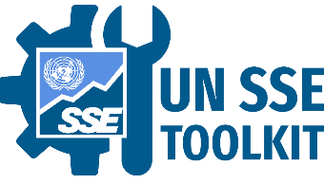 | SSE Toolkit on Sustainability-Related Financial Disclosures  This tool is part of a toolkit that the UN SSE, together with its partners, developed to support stock exchanges and their market participants in the implementation of the IFRS Sustainability Disclosure Standards. The toolkit includes training tools that are designed to complement the SSE Academy’s training program on the IFRS Sustainability Disclosure Standards. The SSE will continue to work with its partners to add new tools as necessary to provide ongoing support to stock exchanges and their markets on this topic.
www.SSEinitiative.org/
disclosure-toolkit/

Foreword
The International Sustainability Standards Board was formed to develop—in the public interest—a comprehensive global baseline of high-quality sustainability disclosures to meet investors’ information needs. Financial markets need this information to assess the risks and opportunities facing individual companies which arise from sustainability-related factors. This is driving significant demand for high-quality information.
The previous alphabet soup of voluntary reporting frameworks and guidance prompted innovation and action. Unfortunately, the fragmented landscape also increased cost and complexity for investors, companies and regulators. There emerged a wide range of voices calling for the IFRS Foundation to build upon market-led initiatives and to use its experience in creating accounting standards required in more than 140 jurisdictions to bring globally comparable reporting on sustainability matters to the financial markets.
The launch of ISSB’s first two standards—IFRS S1 and IFRS S2— in June 2023, ushered in a new era of sustainability-related disclosures in capital markets. The focus now is on supporting jurisdictions in adopting the requirements, and companies in implementing them. Disclosing sustainability information is still a relatively new area for many and there is therefore a big need to develop the new skills required to ensure the ISSB Standards are applied in a high quality and consistent manner. To this end, there is ongoing work with partners around the world on capacity building, including the creation of a dedicated website of free resources to support application, particularly in the global south. In addition to this outreach and education, the ISSB Standards themselves have built in measures to ensure companies are given room to scale up their capabilities.
The Sustainable Stock Exchanges initiative, together with its unique and active network of stock exchanges, is supporting the implementation of the ISSB Standards. The IFRS Foundation is developing an Inaugural Jurisdictional Adoption Guide (Adoption Guide) providing a framework to support jurisdictional regulators, including stock exchanges responsible for listing rules, in their journey to introduce and adopt IFRS S1 and IFRS S2. The Adoption Guide will include the principles that the IFRS Foundation will use to monitor and assess jurisdictional progress towards the adoption of ISSB Standards and the categories for the classification of jurisdictions in accordance with their adoption approaches. The ultimate goal of the Adoption Guide is to facilitate consistent approaches to adoption of ISSB Standards while supporting regulators and entities in transitioning to full application of IFRS S1 and IFRS S2.
The SSE Model Guidance on Sustainability-Related Financial Disclosures does not intend to determine suitable jurisdictional adoption approaches. Rather it is designed to help complement and articulate how stock exchanges can support reporting entities applying the ISSB Standards, providing stock exchanges with accessible, user-friendly guidance that can be helpful to support the implementation journey of globally consistent yet locally relevant disclosure practices using the ISSB Standards for entities listed on SSE member stock exchanges.
The SSE Model Guidance is freely available, which supports emerging market access and works to level the playing field. This is brought to life through proportionality mechanisms, included in IFRS S1 and IFRS S2, that make entry fair for entities, including smaller entities. It addresses a varying range of capabilities and preparedness of companies that apply ISSB Standards.
We applaud the SSE and encourage all stock exchanges to utilise the SSE Model Guidance when guiding their listed entities on the application of the ISSB Standards.

Jingdong Hua
Vice Chair
International Sustainability Standards Board (ISSB)
IFRS Foundation

Preface – A note to stock exchanges
The SSE Model Guidance on Sustainability-Related Financial Disclosures (the/this guidance) has been developed to aid stock exchanges as they provide guidance to their markets in the application of the IFRS Sustainability Disclosure Standards (ISSB Standards). Stock exchanges are encouraged to use chapters 1-5 of this guidance as a template and starting point, for training and education of entities applying the ISSB Standards.
Stock exchanges have a unique role in their markets to help listed companies navigate disclosure demands and requirements. This Guidance helps stock exchanges guide companies in diagnosing their current disclosure practices and mapping a path toward full alignment to global standards. This is done through technical detail on the requirements of the ISSB Standards, practical guidelines on integrating sustainability-related risks and opportunities into governance, strategy development and risk management practices, and through an explanation of how to effectively communicate these practices to investors. This model guidance provides stock exchanges with the building blocks for guidance and education, in support of the global implementation of the ISSB Standards.
While this guidance provides a general overview of IFRS S1 (general disclosures) and IFRS S2 (climate disclosures), it does not aim to replicate existing materials but rather provide practical and easy-to-follow explanation of the ISSB Standards for listed companies at all stages of their climate and sustainability reporting journeys. This model guidance aims to complement rather than replace previous UN SSE model guidance publications, and therefore stock exchanges can additionally make use of the UN SSE’s Model Guidance on ESG disclosures (2015) and Model Guidance on Climate Disclosures (2021) for additional explanations pertaining to environmental, social and governance (ESG) issues as well as climate-related disclosure specificities.
This Guidance is part of a toolkit that the UN SSE, together with its partners, developed to support stock exchanges and their market participants in the implementation of the IFRS Sustainability Disclosure Standards. The toolkit includes training tools that are designed to complement the SSE Academy’s training program on the IFRS Sustainability Disclosure Standards. The SSE will continue to work with its partners to add new tools as necessary to provide ongoing support to stock exchanges and their markets on this topic. Stock exchanges may wish to include these support documents, and other tools they identify, together with their own guidance to companies. To access the toolkit, visit www.sseinitiative.org/disclosure-toolkit/

Copying this guidance
The IFRS Foundation’s International Sustainability Standards Board (ISSB) has reviewed this guidance to ensure that it accurately represents the Standards and encourages stock exchanges to utilize the SSE Model Guidance when providing guidance on sustainability-related financial disclosures. It is important that markets adopt the IFRS Sustainability Disclosure Standards exactly as they are. When guiding markets, exchanges can support the implementation of the ISSB Standards by additionally providing bespoke guidelines which present the ISSB Standards within the local regulatory context.
It should be noted that this guidance is to be used for educational purposes only. The purpose of this guidance is to help stock exchanges to develop their own voluntary guidance to support their listed entities in the implementation of IFRS S1 and S2 standards. The IFRS Foundation permits stock exchanges to reproduce the material in this guidance, provided that the educational material is available free of charge.
However, stock exchanges that have regulatory authority and would like to integrate the ISSB Standards into listing requirements are required to obtain a license from the IFRS Foundation to do so and are encouraged to use the IFRS Foundation’s Adoption Guidance (forthcoming).

Guidance Context
Integrating sustainability-related policies and practices into a company’s strategy and daily operations is increasingly regarded by investors as relevant to the company’s ability to manage and realize long-term value. Effective disclosure of corporate sustainability information enables informed investment and economic decisions (thus supporting the proper functioning of capital markets), while strengthening trust, efficiency, and transparency. As a result, financial institutions now routinely analyze companies’ sustainability-related practices and performance when assessing actual or potential investments. Financial institutions rely on a range of sources for the purpose of assessing companies’ ESG practices and performance, including the company’s own public disclosures.
A variety of corporate reporting and disclosure frameworks, practices and expectations have developed since the 1990s as awareness about the interdependence between economic, social and environmental systems increased. Frameworks and practices focused on corporate sustainability have continued to evolve in response to the demand for information from companies about how they use and affect a broad range of resources to create value and how they manage their dependencies and impacts on the environment and society. While the developments in corporate sustainability reporting are welcome and appropriate responses to the complex issues with which companies must contend, together they present a complex reporting landscape. This has led to calls for corporate sustainability reporting to be standardized and to be integrated with existing mainstream corporate reporting activities, including financial statements and governance disclosures.
In response to these demands, the International Financial Reporting Standards (IFRS) Foundation established the International Sustainability Standards Board (ISSB) at COP26 in November 2021. The ISSB was formed to develop a comprehensive baseline of high-quality sustainability-related financial disclosure standards that build on existing market-led initiatives and that meet investors’ information needs. The work has strong international support from the G7, the G20, the International Organization of Securities Commissions (IOSCO), the Financial Stability Board and Finance Ministers and Central Bank Governors from more than 40 jurisdictions.
In June 2023, the IFRS Foundation ushered in a new era of sustainability-related disclosures in capital markets worldwide with the launch of the IFRS Sustainability Disclosure Standards (also known as the ISSB Standards). The initial two standards launched were IFRS S1 General Requirements for Disclosure of Sustainability-related Financial Information and IFRS S2 Climate-related disclosures. These Standards are being positioned as a global baseline for disclosure of sustainability-related financial information. IOSCO has endorsed the IFRS Sustainability Disclosure Standards as fit for purpose for capital markets, enabling pricing of sustainability-related risks and opportunities and to facilitate enhanced data collection and analysis.
This guidance provides an educational overview of how to apply the ISSB Standards. As this guidance provides a high-level overview of the baseline requirements, it applies to the application of both IFRS S1 and S2. Given that S2 (on climate-related disclosures) builds directly off the foundational guidance in S1 (general disclosures), this high-level overview presents these two guidelines together.
If exchanges wish to provide more detailed guidance on climate-related disclosures, they can find additional resources in the SSE Model Guidance on Climate Disclosure as well as climate-specific guidelines found throughout this document. For additional guidance on climate-specific metrics, exchanges can also use the SSE Primers accompanying this document on Disclosing Climate-Related Metrics and Transition Plans.
Exchanges and report preparers alike should further make use of the IFRS Sustainability Knowledge Hub to access the most current tools, guidelines, and educational assistance on this topic.

Structure of this guidance
This guidance is structured according to a four-step approach (figure I) to enhance disclosure practices. This process is designed to help report preparers build a solid understanding of financially-material sustainability disclosures, ensure that all financially material issues are integrated into existing or new processes and the strategy to address them is effectively communicated. These four steps should be seen as a cycle of continuous enhancement to update practices and re-evaluate changing sustainability-related risks and opportunities facing organizations. To further support market participants in progressing through these four steps, stock exchanges should also consider hosting training with the SSE Academy on this topic, which follows the same four steps.

Figure I – The four-step approach to sustainability-related financial disclosures
Source: UN SSE initiative
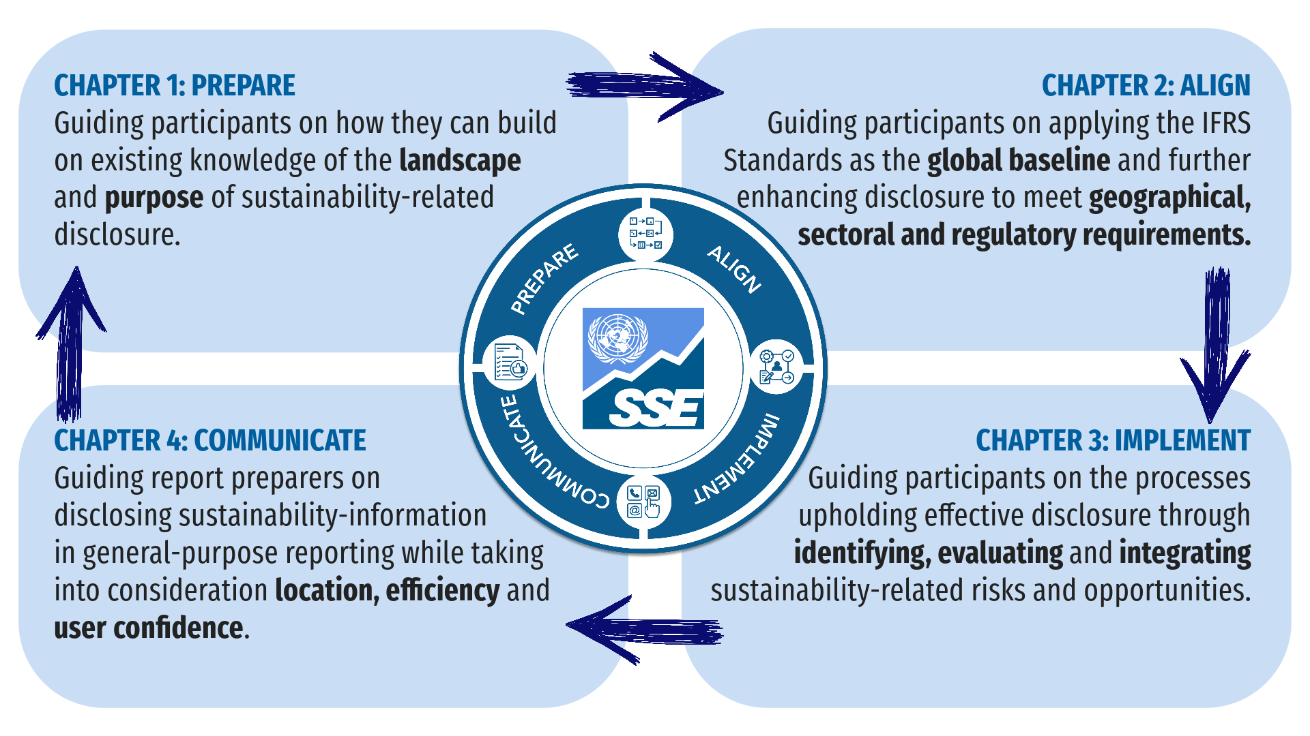

What exchanges can do?
Stock exchanges have a unique yet essential role to support their markets and contribute to the market infrastructure required for application and adoption of the IFRS Sustainability Disclosure Standards. Key actions that exchanges can consider taking as they get started on this topic include:
- Lead by example: Put the standards into practice yourself, to learn from the process and help identify if any additional support would be required for your market and to inspire issuers with your example.
- Guidance: To ensure consistent application of the ISSB Standards, guide listed entities to existing guidance and educational materials developed by the IFRS Foundation to support disclosures. Develop new or update existing disclosure guidance to ensure your market has clear and globally-consistent guidance on the IFRS Standards. Make use of this SSE Model Guidance to ensure that your guidance is globally consistent, while ensuring that you’re also connecting these guidelines to the local context, particularly in section 2.2 (additional disclosures).
- Education and training: Help your market build capacity and knowledge on key sustainability-related topics through training and education programs. Consider hosting training with the SSE Academy, which provides a free training program on applying the IFRS Standards that builds off this Model Guidance.
- Enable market-wide engagement: Coordinate with the IFRS Foundation, regulators and other stakeholders on jurisdictional adoption to ensure a consistent approach is taken. Consider facilitating or contributing to an implementation consortium, together with issuers, investors, regulators and advisors/auditors.
- Support the global baseline: Encourage listed entities to fully apply the ISSB Standards and consult with the IFRS Foundation to advance discussions on adoption into regulatory requirements.
Table of Contents
Acknowledgements i
About UN SSE i
Note i
Foreword ii
Preface – A note to stock exchanges iii
Guidance Context iv
Structure of this guidance v
What exchanges can do v
Chapter 1 – Prepare 1
1.1 Purpose 1
Investor demand 2
Disclosure objectives 3
Differentiating disclosure purpose and audiences 3
1.2 Landscape 4
Alignment of sustainability disclosure frameworks 4
The IFRS Foundation and the ISSB 5
Terms in IFRS Sustainability Disclosure Standards 6
1.3 Additional Resources for Preparation 7
Chapter 2—Align 8
2.1 Global baseline 8
IFRS Sustainability Disclosure Standards – An overview 9
Core content areas in IFRS S1 and IFRS S2 11
2.2 Additional disclosures 18
2.3 Additional Resources for Alignment 19
Chapter 3 – Implement 20
3.1 Identify 20
The type of sustainability-related risks and opportunities to include 21
3.2 Evaluate 24
Evaluating materiality 24
Scenario analysis for testing resilience 27
3.3 Integrate 28
Making use of a disclosure strategy 29
3.4 Additional Resources for Implementation 31
Chapter 4—Communicate 32
4.1 Disclosure location and timing 32
Materiality and location of disclosure 33
Cross-referencing 33
Timing 34
4.2 Effective and efficient communication 35
Connected information 35
Aggregation and disaggregation 36
Avoiding duplication 36
Comparative information and changes in metrics 36
Reporting with other information in general purpose financial reports 36
4.3 Building confidence 37
Dealing with uncertainty and correcting prior period errors 37
Providing comparative information about estimated metrics 38
Commercially sensitive information 39
Statement of compliance 39
Assurance 39
4.4 Additional Resources for Communication 40

Figures
Figure I – The four-step approach to sustainability-related financial disclosures | v
Figure 2.1 – IFRS Sustainability Disclosure Standards are built on widely used standards and frameworks | 9
Figure 2.2 – IFRS first two Sustainability Disclosure Standards, S1 and S2 | 9
Figure 2.3 – Questions answered by IFRS S1 that also apply IFRS S2 | 10
Figure 2.4 – Four core content areas in IFRS S1 and IFRS S2, building off the TCFD | 11
Figure 2.5 – Adding a sustainability reporting building block for multi stakeholder reporting | 19
Figure 3.1 – Questions a disclosure strategy can answer | 30
Figure 4.1 – Dealing with the discovery of new information before report publication | 35
Figure 4.2 – Providing comparative information about redefined or replacement metrics | 39
Tables
Table 2.1 Governance Disclosures Overview | 12
Table 2.1 Strategy Disclosures Overview | 12
Table 2.3 Risk Management Disclosures Overview | 16
Table 2.4 Metrics and Targets Disclosures Overview | 17
Table 4.1 – Deciding on disclosure of material and non-material information in the context of local laws and regulations | 38
Tips for report preparers
Helpful Tip 1.1 – Distinguishing sustainability-related financial information from sustainability in the SDGs and other international policy pronouncements on sustainability | 6
Helpful Tip 2.1 – Time horizons | 14
Helpful Tip 2.2—Trade-offs | 14
Helpful Tip 2.3 - Quantitative information | 15
Helpful Tip 2.4 – Financial position and financial performance | 15
Climate Tip 2.1 Climate-related physical risks and climate-related transition risks | 16
Climate Tip 2.2 Cross-industry metrics | 18
Helpful Tip 3.1 – Resources and relationships | 22
Helpful Tip 3.2 – Identifying sustainability-related risks and opportunities | 24
Helpful Tip 3.3 – Reasonable and supportable information | 25
Helpful Tip 3.4 – Informing decisions of primary users | 26
Helpful Tip 3.5 – Materiality test | 27
Helpful Tip 3.6 – Aggregation and disaggregation | 28

Chapter 1 – Prepare
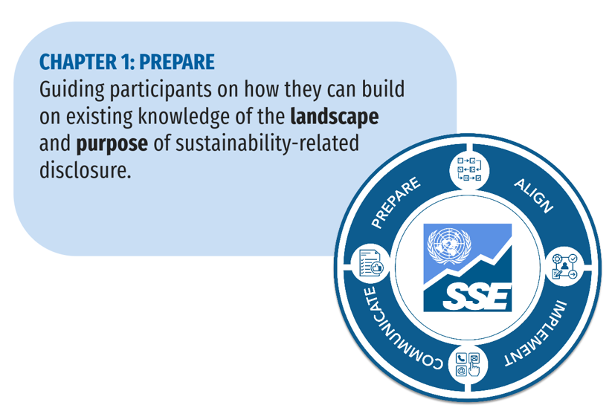
To help companies understand the context within which the IFRS Sustainability Disclosure Standards have been developed, this chapter provides a basic overview of the context report preparers should be familiar with, including the purpose of and demand for enhanced corporate sustainability disclosure, as well as the evolution of the sustainability-related disclosure landscape. The window for managing and minimizing the environmental, social and financial consequences of sustainability issues including inequality, poverty as well as food, water and resource scarcity is closing. The expected impacts of these issues on society and the global economy as well as on companies, have led investors, policy makers and financial institutions to request sustainability information from companies to assess and price sustainability-related issues in the market. Stakeholders require consistent, trustworthy and accurate corporate disclosures so they can assess the risks and opportunities related to these environmental and social challenges.
This Chapter provides guidance on:
- The purpose: The case for and market drivers of sustainability-related financial reporting; and
- The landscape: Widely adopted sustainability-related disclosure frameworks, global standards and compliance requirements.
Companies already advanced in making sustainability disclosures, should consider reviewing developments in the reporting landscape every three to five years to identify any new requirements, practices or science-based advancements that might have emerged. New guidance, resources, tools, educational materials and methods are rapidly evolving to support companies disclosing sustainability information. The IFRS Foundation’s Knowledge Hub collates resources about sustainability-related financial disclosure as required by the IFRS Sustainability Disclosure Standards.

1.1 Purpose
Investors and other stakeholders use varied terms to describe the type of information companies provide about their environmental, social and governance practices. The terms ESG and sustainability information are sometimes used interchangeably because each describes a way to understand how businesses impact, and are exposed to, environmental and social factors. Varied terms have developed to reflect the various objectives information is designed to satisfy and to reflect how various audiences use the information. For example, information might be provided to:
- Satisfy compliance requirements in jurisdictions that have introduced mandatory ESG or sustainability-related reporting;
- Hold governance and management bodies accountable for operating in an ethical, responsible and sustainable manner;
- Show companies’ contributions to national and international commitments such as to the United Nations Sustainable Development Goals (SDGs), Paris Agreement, and Convention on Biological Diversity;
- Identify corporate activities’ impacts on the environment, society and the economy; and
- Show how companies’ abilities to execute their strategies are affected by the sustainability-related risks to which companies are exposed and the opportunities they can maximize, for example, by developing low-carbon products.
Some types of information simultaneously satisfy multiple objectives. For example, information about greenhouse gasses emitted from a company’s operations might be required under the laws of some jurisdictions and it is also relevant for showing a company’s impacts on the environment and society, whether it is operating sustainably, how it contributes to the goals of the Paris Agreement and the extent to which it is exposed to risk. Other types of information are specific to the purpose of, and audience for, information. For example, a national regulator might require information about some pollutants to gauge progress towards specific national environmental goals.

Investor demand
The IFRS Sustainability Disclosure Standards are designed to elicit disclosures that satisfy investor information needs. This audience is defined as “existing and potential investors, lenders and other creditors” and often referred to in the IFRS standards as “primary users of general purpose financial reports”. Capital market participants are increasingly aware that material sustainability factors affect a company’s long-term value. The largest global investors are allocating capital to companies that are well-equipped to benefit from the transition to a more sustainable economy. They are also increasingly seeking to protect their portfolios from sustainability-related risks. Asset managers and asset owners that have included, or are incorporating sustainability considerations into their investment processes, manage a growing proportion of assets.
Sustainability information provides insight into the quality of corporate management and helps investors better anticipate company performance as it provides a more comprehensive view of the company. For many investors, effective analysis of sustainability factors has become a fundamental part of assessing the value of an investment. As a result, investors are increasingly asking companies to communicate on how they manage sustainability-related risks and opportunities, and, more recently, on how their activity has a sustainable impact on the real economy.
Globally, sustainability is becoming mainstream because investors have widely adopted the evidence-driven view that companies implementing effective sustainability practices may financially outperform their peers, since they are considered to be better managed, more competitive and highly equipped to anticipate and mitigate risks. Growing research suggests company disclosures on sustainability factors, if integrated into investment analysis, might offer investors potential long-term performance advantages. Many investors and investor associations responded to the IFRS Foundation’s 2022 public consultation on the need for global sustainability-related financial disclosure standards, suggesting strong interest from investors and other users of general purpose financial reporting. Respondents included asset managers and asset owners that represent a wide range of financial institutions.
The company should carefully consider its investor composition and resources to ensure it can streamline its sustainability disclosures to best satisfy the information needs of investors. The company should understand:
- Who are its top investors?
- What kind of investors would the company like to have?
- How has the company engaged with investors to understand their concerns?
Companies also should consider whether their investors apply benchmarks in order to assess sustainability performance. For example, ‘GRESB Assessments’ are used by investors and the real estate industry to assess and benchmark sustainability performance of real estate and infrastructure assets.

Disclosure objectives
Reporting on how sustainability considerations relate to strategy, financial performance and valuation helps a company to communicate how it is addressing some of the world’s most pressing challenges, including poverty, inequality, climate change and biodiversity loss. Addressing these challenges fosters more prosperous economic systems that benefit everyone and create more stable and resilient economies. Alongside financial information, sustainability information can paint a complete picture of a company’s performance, helping investors to understand its competitive positioning and the efficiency with which it can benefit from new opportunities. Beyond satisfying investor information needs and reducing information asymmetries, sustainability-related disclosure can yield benefits for companies including improved access to capital, more effective compliance, strengthening corporate performance and enhancing reputation and stakeholder engagement.
Each company would decide why and to what extent it reports sustainability information, which will influence how, where and what is disclosed. Reasons are likely to include:
- To conform with legal, regulatory or listing requirements;
- To satisfy management’s communication objectives, for example to:
  - differentiate against peers; and/or
  - communicate to stakeholders (including investors) about how the company plans to create long-term value through business model design and flexibility, capital investments and transformation programs;
- To respond to societal expectations, demonstrate accountability and align with peer practice, for example to:
  - explain the role the company can play in response to the climate and biodiversity emergency, and towards improved gender equality;
  - explain participation in industry bodies and initiatives;
  - demonstrate good governance and keep their license to operate;
- To respond to investor interest or pressure from investor bodies for disclosure of information.

Differentiating disclosure purpose and audiences
Although ESG frameworks and standards share some content elements and disclosure principles, the terminology used to describe sustainability information and the requirements for providing that information vary according to the purpose of, and audience for, the information. Report preparers should consider three broad views that explain some of the differences between the purposes of and audiences for ESG disclosure:
- The ‘financial materiality’ view—This perspective considers how sustainability-related risks and opportunities affect a company’s performance and prospects. The intended audience for the information is current and prospective investors. Management judges what information is material depending on which factors are reasonably expected to affect the financial results and prospects of the company and its investors’ decision making.
- The ‘impact materiality’ view—This perspective considers how a company’s activities impact society and the environment. The broad audience are multi-stakeholders including investors, employees, business partners, customers and communities. Management judges which information is material through engagement with these stakeholders, impact assessments, or other methods.
- The ‘double materiality’ view— This perspective considers both how a company’s activities impact society and the environment (‘impact materiality’), as well as how sustainability-related risks and opportunities affect the company’s performance and prospects (‘financial materiality’).
These are three interrelated viewpoints about the basis on which a company should provide information and about how companies judge which information is material. For example, a company using the financial materiality view in assessing how sustainability issues affect its financial results could be informed by how its impacts affect resource availability, quality and cost. Therefore, even if the financial materiality view is taken, it is informed by how impacts on the environment and society affect the resources and relationships on which the company’s financial results depend. The outward impact of a company can also have an internal impact on the company by regulations and reputation and, therefore, financial materiality and impact materiality views are interrelated in some cases.

1.2 Landscape
Voluntary sustainability reporting frameworks have been evolving since the 1990s. Although corporate sustainability disclosure continues to evolve, many sustainability frameworks are aligned on some content elements and key concepts. The IFRS Sustainability Disclosure Standards seek to build on existing frameworks and take advantage of their shared characteristics. This guidance aims to support report preparers and the leadership of listed companies to integrate and implement the IFRS Sustainability Disclosure Standards. It is also important for companies to understand the overall disclosure landscape and how the IFRS Sustainability Disclosure Standards relate to other frameworks and standards. This section provides a brief overview of the landscape.

Alignment of sustainability disclosure frameworks
Various projects have explored ways to achieve greater consistency among reporting frameworks to maximize the comparability and usefulness of sustainability information companies provide. For example, the Better Alignment Project, a collaboration between framework and standard-setting institutions, mapped alignment between content requirements, indicators and reporting principles. That project led to greater harmony in reporting requirements, including the IFRS Foundation’s development of a global baseline for sustainability-related financial disclosure.
Although their purpose or audience vary, many reporting standards and frameworks are aligned in the structure and components of information content (content elements) required and the criteria companies are required to apply to ensure that information is useful for decision-making (described here as ‘disclosure principles’).
Many sustainability reporting standards and frameworks are accompanied by resources including guidance on how to prepare disclosures, measurement methodologies, processes to be used for preparing information and examples of reporting practice. For the most current resources and guidelines, companies are encouraged to refer to the IFRS website (and knowledge hub) and make use of the guidance, tools and educational materials provided to support them in disclosing sustainability-related financial information.

Core content elements
Content elements in many sustainability reporting frameworks include:
- Governance requirements, including information about the company’s oversight of sustainability strategy, policies and information;
- Strategy requirements, including how a company’s strategic objectives, risk management and opportunity maximization incorporate consideration of and are affected by sustainability matters;
- Risks and opportunities, including how sustainability-related risks and opportunities are identified, assessed and managed; and
- Metrics and targets, including how a company measures and monitors sustainability-related risks and opportunities and the targets used to manage and mitigate risks and maximize opportunities.
Within these categories of content, companies are asked to provide information on a range of subjects including human rights, labor practices, environment (including biodiversity and climate change) and anti-corruption practices.
Many standards and frameworks also specify reporting principles a company applies to ensure that information is coherent, robust, decision-useful and aligned with the objectives, audience for and other content of corporate reports. Some disclosure principles are shared by varied standards and frameworks, although slightly different language might be used. For example, many standards and frameworks require information to be relevant, material, complete, reliable, specific, clear, balanced and understandable.
Companies are asked to provide operational, analytical and forward-looking information.
- Operational information includes:
  - measurements taken from direct readings, observations or estimates about physical properties such as the quantity of resources/capital consumed or used and/or the quantity of outputs and releases such as waste and emissions; and
  - details of processes and procedures operated by the company.
- Analytical information discusses, assesses and analyzes the procedural, strategic, business and financial implications of the company’s environmental, social and governance results and plans.
- Forward-looking information provides insight into future activity and its impact or potential impact on the business, the environment and society.

The IFRS Foundation and the ISSB
The IFRS Foundation is a not for profit, public interest organization established to develop high-quality, understandable, enforceable and globally accepted accounting and sustainability disclosure standards. IFRS Accounting Standards developed by the International Accounting Standards Board (IASB) are required for use by more than 160 jurisdictions around the world. The IFRS Sustainability Disclosure Standards are developed by the International Sustainability Standards Board (ISSB). The Trustees of the IFRS Foundation, who are accountable to a monitoring board of public authorities, govern the IASB and the ISSB.
The ISSB works closely with the IASB to ensure that the Sustainability Disclosure Standards complement the Accounting Standards in requiring a company to provide investors with transparent and reliable information that is decision-useful. A company is also required to provide information about sustainability factors that could create or erode its value in the short, medium and long term.
The ISSB’s main objectives are as follows:
- Develop standards for a global baseline of sustainability disclosures: In order to advance this objective, the IFRS Sustainability Disclosure Standards build on the sustainability disclosure standards and frameworks that were already widely in use (figure 2.1). Some of the organizations that created such standards have been consolidated into the IFRS Foundation, including the Climate Disclosure Standards Board (CDSB) and the Value Reporting Foundation (VRF) (previously the International Integrated Reporting Commission (IIRC) and Sustainability Accounting Standards Board (SASB)). The IFRS Sustainability Disclosure Standards also draw on the structure and content of recommendations published by the Task Force on Climate-related Financial Disclosures (TCFD) and the IFRS Foundation will take over the monitoring of the progress on companies’ climate related disclosures from 2024. This global baseline is designed to form a foundation for disclosure with the flexibility for national and regional policymakers to add additional or extended requirements to meet: Jurisdiction-specific requirements; and/or Broader multi-stakeholder needs.
- Meet the information needs of investors: The IFRS Sustainability Disclosure Standards require companies to provide decision-useful information for the ‘primary users of general purpose financial reports’ (primary users). The primary users of general purpose financial reports are defined in IFRS Sustainability Disclosure Standards as ‘existing and potential investors, lenders and other creditors’.
- Enable companies to provide comprehensive sustainability information to global capital markets: The IFRS Sustainability Disclosure Standards are designed to help participants in global capital markets understand how sustainability-related risks and opportunities affect a company’s businesses and prospects.
- Facilitate interoperability with disclosures that are jurisdiction-specific and/or aimed at broader stakeholder groups: The IFRS Sustainability Disclosure Standards do this by providing a common baseline and language for sustainability-related disclosures to which additional or extended requirements can be added.

Terms in IFRS Sustainability Disclosure Standards
This guide focuses on the sustainability information specifically relevant to investors and adopts the term ‘sustainability-related financial information’ from the IFRS Sustainability Disclosure Standards. The IFRS Sustainability Disclosure Standards use some terms that are also used in other sustainability reporting frameworks. However, those terms have specific meanings defined in the standards, which companies are required to use when they apply the IFRS Sustainability Disclosure Standards.

Sustainability-related financial information
The IFRS Sustainability Disclosure Standards require entities to disclose sustainability-related financial information in general purpose financial reports. Sustainability-related financial information is different from information about how a company contributes to the SDGs (see explainer 1.1). Sustainability-related financial information is information about a company’s sustainability-related risks and opportunities that is useful to primary users of general purpose financial reports in making decisions about providing resources to the company. Sustainability-related risks and opportunities are those that could reasonably be expected to affect the company’s cash flows, access to finance or cost of capital over the short, medium or long term. These ‘sustainability-related risks and opportunities could reasonably be expected to affect the company’s prospects.’ Specific requirements apply to information about climate-related risks and opportunities. Chapter 2 ‘Align’ provides further information on the content preparers should disclose to align with IFRS Sustainability Disclosure Standards. Chapter 3 ‘Implement’ provides information about how to identify sustainability and climate-related risks and opportunities.

Helpful Tip 1.1 – Distinguishing sustainability-related financial information from sustainability in the SDGs and other international policy pronouncements on sustainability
The IFRS Sustainability Disclosure Standards focus on information about the sustainability-related risks and opportunities that could reasonably be expected to affect the company’s cash flows, access to finance or cost of capital over the short, medium or long term. The SDGs and international policy pronouncements such as the Paris Agreement apply widely across many social and ecological phenomena and their purpose is to provide a blueprint for peace and prosperity for people and the planet now and in the future. However, understanding how the sustainability and climate-related risks and opportunities set out in the IFRS Sustainability Disclosure Standards relate to established wider notions of sustainability and sustainable development is pivotal to understanding the scope of the IFRS Sustainability Disclosure Standards. Therefore, a company is required to consider relationships between the impacts of its activities on the environment and society, as well as the impacts of the environment and society on its cash flows, cost of capital and access to finance.

1.3 Additional Resources for Preparation
- IFC Beyond the Balance Sheet platform – a one-stop shop on sustainability and climate reporting tailored for emerging markets.
- IFRS Foundation website, including ISSB Standards and accompanying guidance, plus IFRS knowledge hub - Provides access to the most current tools, guidelines, and educational assistance on the IFRS Sustainability Disclosure Standards.
- IFRS Foundation, ISSB Updates - Highlights preliminary decisions of the ISSB, summarizing monthly meetings of the International Sustainability Standards Board.
- UNDP, The Climate Dictionary - Providing an everyday guide to understanding climate change.
- UN PRI, Signatory update - For up to date data on the number of investors that are signatories of the PRI, as well as the latest products, tools, initiatives and collaborations

Chapter 2—Align
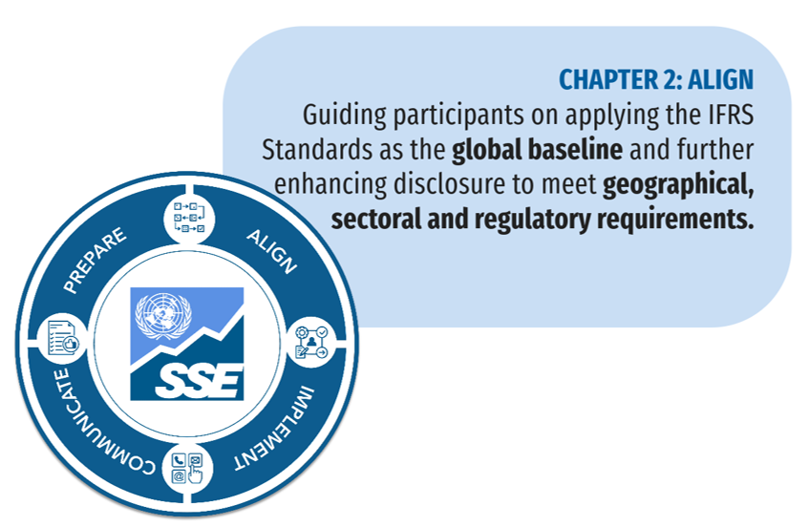
The ‘Align’ step sets the foundation for a company to ensure their disclosure strategy and practices apply the IFRS Sustainability Disclosure Standards. However, companies should also take account of applicable geographical or sectoral requirements as well as peer practices and leadership objectives.
The IFRS Sustainability Disclosure Standards are described as a global baseline because they are intended to be applied with disclosures. As a result, this chapter focuses primarily on companies applying the IFRS Sustainability Disclosure Standards as a baseline and as the foundation for other enhancements to corporate disclosure, providing guidance on:
- Global baseline - applying the IFRS Sustainability Disclosure Standards, by explaining the specific content a company is required to disclose and how the company is required to organize the information to make it decision-useful.
- Additional disclosures - how to deal with other disclosures, for example to comply with regulatory requirements or to meet the information needs of broader stakeholders.

2.1 Global baseline
As noted in Chapter 1, the IFRS Sustainability Disclosure Standards were built on sustainability disclosure standards and frameworks that were already widely in use (figure 2.1). The standards were developed to require companies to provide decision-useful information for the ‘primary users of general-purpose financial reports’, defined as ‘existing and potential investors, lenders and other creditors.

Figure 2.1 – IFRS Sustainability Disclosure Standards are built on widely used standards and frameworks
Source: IFRS Foundation
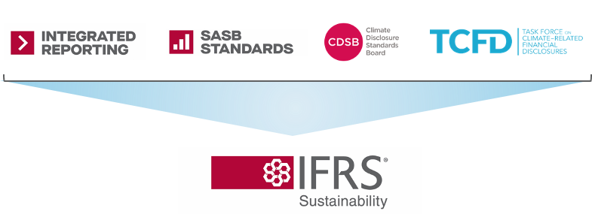
This global baseline is designed to form a foundation for disclosure with the flexibility to add additional or extended disclosures (known as the building blocks approach) to meet:
- Jurisdiction-specific requirements (for example, the European Sustainability Reporting Standards ,ESRS, that apply to EU and non-EU companies subject to the Corporate Sustainability Reporting Directive 2022/2464); and/or
- Broader multi-stakeholder needs (for example, The GRI Standards for Sustainability Reporting).

IFRS Sustainability Disclosure Standards – An overview
In June 2023, the IFRS Foundation issued two IFRS Sustainability Disclosure Standards (figure 2.2). Extracts from IFRS S1 and IFRS S2 are cited in this Guidance to help companies understand the requirements. Relevant paragraph numbers from IFRS S1 and IFRS S2 are noted in the text for ease of reference using the format IFRS S1 or IFRS S2 and the paragraph number to which the Guidance relates. Companies are strongly encouraged to read the standards in full.

Figure 2.2 – IFRS first two Sustainability Disclosure Standards, S1 and S2
Source: IFRS Foundation
IFRS S1 | General Requirements for Disclosure of Sustainability-related Financial Information, including how sustainability-related financial disclosures should be prepared and the requirements for the content and presentation of those disclosures in general purpose financial reports.
IFRS S2 | Climate-related Disclosures include specific strategy disclosure requirements for climate-related risks and opportunities including climate-related transition plans and the use of scenario analysis for climate resilience, as well as specific metrics and targets including greenhouse gas (GHG) emissions.

Apply IFRS S1 and IFRS S2 together
Companies are required to apply IFRS S2 in accordance with IFRS S1 because IFRS S1 sets out key concepts and requirements that also apply to information required by IFRS S2. For example, the ‘qualitative characteristics of useful sustainability-related information’ in Appendix D to IFRS S1 also apply to information required by IFRS S2. Therefore, sustainability-related financial information, including climate-related financial information, is required to be relevant, material and faithfully represented as well as comparable, verifiable, timely and understandable.
Because companies are required to apply IFRS S2 in accordance with IFRS S1, information about the content requirements of both IFRS Sustainability Disclosure Standards is provided in this chapter. The requirements relating to general sustainability-related information apply to climate-related information. However, if IFRS S2 sets out specific requirements relating to climate disclosure in this guidance, they are identified as ‘climate specifics.’
IFRS S1 sets out the conceptual foundations companies are required to apply in complying with either IFRS S1 or IFRS S2 that help with making sustainability-related financial information useful. The concepts mirror the conceptual foundations for financial reporting. Figure 2.3 outlines the conceptual foundations in IFRS S1 that are also applicable to IFRS S2.

Figure 2.3 – Questions answered by IFRS S1 that also apply IFRS S2
Source: SSE Initiative
Note: IFRS S1 requirements apply to any company applying IFRS Sustainability Disclosure Standards. Even companies that plan only to apply IFRS S2 Climate-related Disclosures are required to comply with IFRS S1.
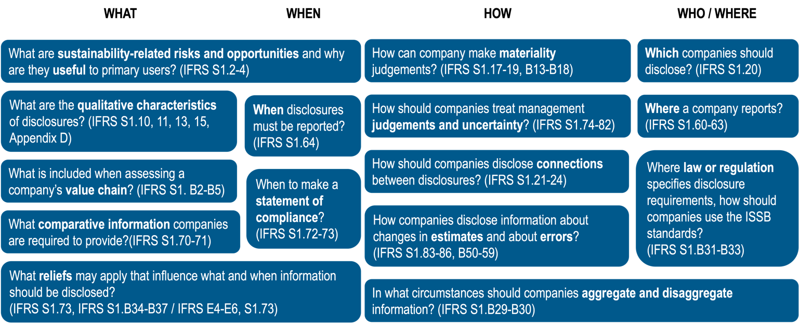
The IFRS Foundation also published:
- Application guidance, presented in an appendix to each Standard to provide companies with guidance on IFRS S1 and IFRS S2, with the same authority as other parts of the Standard;
- Educational material, which is separate material developed to help companies apply the standards;
- Illustrative guidance and examples, providing guidance using hypothetical examples. This guidance is not a part of the Standards and does not provide any interpretation of the Standards; and
- Industry-based guidance for IFRS S2, providing guidance to companies for identifying climate-related risks and opportunities. Also, when applying the requirements of IFRS S2 on metrics and targets (see Annex A), companies are required to refer to and consider the industry-based metrics.
- Bases for conclusions, summarizing the ISSB’s deliberations when developing IFRS S1 and IFRS S2. This may be helpful in cases when a report preparer is unsure about the reason behind why a certain disclosure requirement is the way it is.
The ISSB will consider developing IFRS Sustainability Disclosure Standards on other topics over time, reflecting feedback on its priorities and the IFRS Foundation’s due process. Until the development of further topic-specific standards, companies should refer to the process for identifying sustainability-related risks and opportunities described in Chapter 3. The ISSB also proposes creating an IFRS Sustainability Disclosure Taxonomy to get the benefits of digital reporting based on IFRS S1 and IFRS S2.

Core content areas in IFRS S1 and IFRS S2
The core content areas set out the type of information about which a company is required to provide disclosures. The content in IFRS S1 and IFRS S2 applies the same four-part structure that many companies are already using if they disclose climate-related information in alignment with the TCFD: Governance, Strategy, Risk management, and Metrics and targets (figure 2.4).

Figure 2.4 – Four core content areas in IFRS S1 and IFRS S2, building off the TCFD
Source: IFRS Foundation
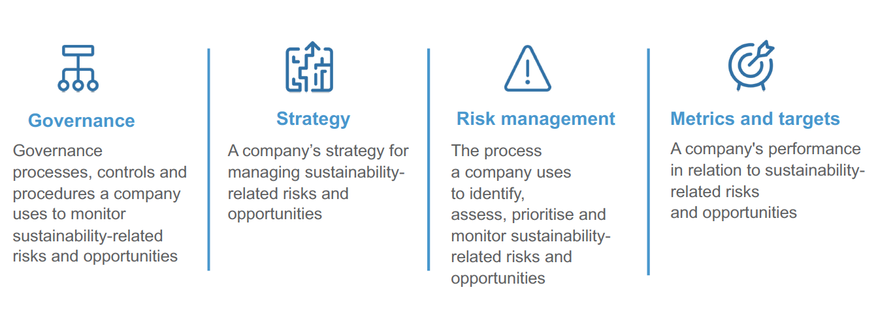

Governance
Disclosure requirements on governance (table 2.1) are designed to enable users of general purpose financial reports to understand the governance processes, controls and procedures a company uses to monitor, manage and oversee sustainability-related risks and opportunities. IFRS S1 and IFRS S2 require that a company disclose information about the governance, management and oversight of sustainability-related risks and opportunities (including climate). Governance disclosures include information pertaining to both the governance body as well as the management’s role in governance, such as:
- Which board and management bodies or committees are responsible for the management, monitoring and oversight of sustainability risks and opportunities;
- The role, responsibilities, skills and competencies of the members of these boards, bodies or committees;
- What processes and controls these management boards, bodies or committees use for managing sustainability risks and opportunities;
- How and when these boards, bodies or committees get informed about sustainability-related risks and opportunities; and
- What sort of decisions these management boards, bodies or committees make, including what targets they set to manage sustainability-related risks and opportunities.
Chapter 3 of this Guidance provides more information on how to identify sustainability-related risks and opportunities.

Table 2.1 Governance Disclosures Overview
Source: UN SSE
Companies applying the IFRS Sustainability Disclosure Standards are required to disclose information about:
S1 | The governance body  The body that is responsible for oversight of sustainability-related risks and opportunities, including:  - How are responsibilities for sustainability-related risks and opportunities reflected in the terms of reference, mandates or policies applicable to the governance body?  - Are the skills and competencies of the individuals on the governance body appropriate for overseeing sustainability-related risks and opportunities?  - How and how often is the governance body informed about sustainability-related risks and opportunities?  - How does the governance body take account of sustainability-related risks and opportunities when overseeing the company’s strategy, making decisions and setting targets for managing sustainability-related risks and opportunities?
S1 | Management’s role in governance  The controls and procedures used to manage and oversee sustainability-related risks and opportunities, including:  - How are roles delegated and to whom/which management bodies?  - Which controls and procedures are used to support oversight of sustainability-related risks and opportunities and how are they integrated with other control functions?

Strategy
IFRS S1 and S2 disclosure requirements on strategy (table 2.2) are designed to enable users of general purpose financial reports to understand a company’s strategy for managing sustainability-related risks and opportunities. IFRS S1 requires companies to disclose information about the sustainability-related risks and opportunities that have been identified and the time horizons over which they are expected to occur, including:
- The effect of those risks and opportunities on the company’s business model and value chain;
- The effect of those risks and opportunities on the company’s strategy and decision-making;
- The effect of those risks and opportunities on the company’s financial position, performance and cash flows; and
- The resilience of the company’s strategy and business model to the effect of those risks and opportunities.
Chapter 3 provides more guidance on using climate scenarios to assess the resilience of the business model and strategy to climate-related risks.

Table 2.2 Strategy Disclosures Overview
Source: UN SSE
Companies applying the IFRS Sustainability Disclosure Standards are required to disclose information about:
S1 | Sustainability-related risks and opportunities  Companies applying the IFRS Sustainability Disclosure Standards are required to disclose information about sustainability-related risks and opportunities they have identified, including:  - The sustainability-related risks and opportunities that could reasonably be expected to affect the company’s prospects (IFRS S1.30(a));  - The time horizons — short, medium or long term – over which the effects of the sustainability-related risks and opportunities could reasonably be expected to occur (IFRS S1.30(b)) (see Explainer 2.1); and  - How the company defines short, medium and long term and how those definitions are linked to the planning horizons used by the company for strategic decision-making (IFRS S1.30(c)).
S2 | - Climate-related risks include physical and transition risks. To comply with IFRS S2, a company is required to disclose whether it considers the risks it identified as physical or transition risks (IFRS S2.3).  - When identifying climate-related risks and opportunities, a company shall refer to and consider the applicability of disclosure topics defined in Industry-based Guidance on Implementing IFRS S2 (IFRS S2.12).
S1 | Current and anticipated effects on business model and value chain  A company is required to describe the current and anticipated effects of sustainability-related risks and opportunities on the company’s business model and value chain, including where the effects of these risks and opportunities are concentrated (for example, in geographical areas, facilities and types of assets) (IFRS S1.32)).  A value chain encompasses the interactions, resources and relationships a company uses and on which it depends to create products and services across their whole life cycle from conception to delivery, consumption and end of life (IFRS S1 Appendix A).
S1 | Effect on strategy and decision-making  A company is required to disclose information about:  - Its actual and planned response to sustainability-related risks and opportunities in its strategy and decision-making (IFRS S1.33(a));  - Progress toward any plans previously disclosed, including qualitative and quantitative information (IFRS S1.33(b)); and  - Trade-offs (see Explainer 2.2 below) between sustainability-related risks and opportunities (IFRS S1.33(c)).
S2 | - Details of how the company plans to achieve any climate-related targets including greenhouse gas emissions targets it has set and any targets it is required to meet by law or regulation (IFRS S2.14(a) and 14(a)(v));  - Current and anticipated changes to the business model attributable to climate-related risks and opportunities including changes in resource allocation, plans to manage or decommission carbon, energy or water-intensive operations, changes in demand or supply chain, or investments and expenditure, including on research and development, acquisitions and divestments (IFRS S2.14(a)(i));  - Current and anticipated direct mitigation and adaptation efforts, for example, changes in production processes or equipment, relocation of facilities, workforce adjustments and changes in product specifications (IFRS S2.14(a)(ii)); and  - Current and anticipated indirect mitigation and adaptation efforts, for example, through working with customers and supply chains (IFRS S2.14(a)(iii)).
S1 | Effects on financial position, financial performance and cash flows  A company is required to disclose quantitative and qualitative information about the financial effects of sustainability-related risks and opportunities:  - For the reporting period (current and anticipated financial effects) (IFRS S1.35(a) and (b)), including:  - the effect on financial position (see Explainer 2.3), performance and cash flows; and  - how those effects might give rise to the risk of a material adjustment to the carrying amounts of assets and liabilities reported in the next annual reporting period.  - Over the short, medium and long term IFRS S1.35(c), including how the financial position is expected to change and taking into consideration:  - the strategy to manage sustainability-related risks and opportunities; and  - investment and disposal plans, including plans to which the company is not contractually committed; and  - planned sources of funding to implement the strategy.  - Over the short, medium and long term IFRS S1.35(d), including how the financial performance is expected to change given the company’s strategy to manage sustainability-related risks and opportunities.
S2 | - A company is required to disclose information about climate-related financial flows. Such information could include, for example, increased revenue from products and services aligned with a lower-carbon economy, costs arising from physical damage to assets from climate events and expenses associated with climate adaptation or mitigation (IFRS S2.16(d)).
S1 | Resilience  A company is required to disclose information that enables investors to understand the company’s capacity to adjust to the uncertainties arising from sustainability-related risks. That disclosure includes a qualitative or quantitative assessment of the resilience of its strategy and business model and explains how and when the company carried out that assessment.
S2 | - A company is required to use climate-related scenario analysis to assess the resilience of its strategy and business model to climate-related risks and opportunities (IFRS S2.22).  - The company is required to disclose information that enables users of general purpose financial reports to understand:  - the implications of the company’s resilience assessment, including potential responses to the possible outcomes identified in the scenario analysis (IFRS S2.22(a)(i)).  - areas of uncertainty that affect the company’s resilience assessment (IFRS S2.22(a)(ii))).  - the company’s capacity to adjust its strategy and business model over the short, medium and long term. The company is required to include information about the availability and flexibility of financial resources, capacity to maximize opportunities, ability to redeploy, repurpose or decommission existing assets and the effect of current and planned investments in climate mitigation and adaptation (IFRS S2.22(a)(iii)).  - how and when the company did its climate-related scenario analysis, including how many and what type of scenarios the company used and why (for example, a diverse range of scenarios covering both physical and transition risks and whether scenarios aligned with the latest international agreement on climate change were used). The disclosure is also required to include the time horizons and scope of operations to which the analysis applied (IFRS S2.22(b)(i) and (iii)).  - key assumptions used for the analysis (IFRS S2.22(ii)).

Helpful Tip 2.1 – Time horizons
Definitions of short-, medium- and long-term time horizons can vary between companies and depend on many factors, including industry-specific characteristics and the time horizons over which users of general purpose financial reports conduct their assessments of companies in a given industry (IFRS S1.31). Depending on their particular circumstances, companies might define time horizons by reference to investment and business cycles, or strategic planning horizons, the life of assets or other factors.

Helpful Tip 2.2—Trade-offs
The IFRS Sustainability Disclosure Standards do not define ‘trade-offs’, but in general the concept refers to situations where there is a need to balance disadvantages in some aspects against gains in other aspects. IFRS S1.B44 provides the example of a company that considers the potential effects of restructuring its operations in response to a sustainability-related risk on the future size and composition of its workforce. The Integrated Reporting Framework (paragraph 5.8) provides other examples of trade-offs including:
- Between capitals or between components of capital (for example, creating employment through an activity that negatively affects the environment);
- Over time (for example, choosing one course of action when another course would result in superior capital increment but not until a later period); and
- Between capitals owned by the company and those owned by others or not at all.

Helpful Tip 2.3 - Quantitative information
Qualitative information may be disclosed as a single amount or as a range (IFRS S1.36 and S2.17), and is not required if:
- the current and anticipated financial effects of sustainability-related risks and opportunities are not separately identifiable (IFRS S1.37(a) and S2.19(a));
- the level of measurement uncertainty in estimating the effects of sustainability risks and rewards is so high that the information would not be useful (IFRS S1. 37(b) and S2.19(b));
- the company does not have the skills, capabilities or resources to provide quantitative information on anticipated financial effects (IFRS S1.39 and S2.20).
If the conditions for not providing quantitative information are satisfied, the company shall: explain why it has not provided quantitative information (IFRS S1.40(a) and S2.21(a)); provide quantitative information about the combined financial effects of sustainability-related risks and opportunities and other relevant factors, unless information about the combined financial effects would not be useful (IFRS S1.40(c) and S2.21(c)); and provide qualitative information (IFRS S1.40(b) and S2.21(b)).
The qualitative information a company is required to disclose includes the line items, totals and subtotals likely to be affected or that already have been affected by the effects of sustainability-related risks and opportunities.

Helpful Tip 2.4 – Financial position and financial performance
Financial position is described in The Conceptual Framework for Financial Reporting as ‘information about the company’s economic resources and the claims against the reporting company.’ An ‘asset’ is a present economic resource controlled by the company as a result of past events. The statement of financial position recognises assets, liabilities and owner’s equity. Information about sustainability-related risks and opportunities is unconstrained by definitions of assets and liabilities or the criteria for recognising them.
Statements of financial performance show income and expenses. Information about a company’s financial performance helps investors to understand the return that the company has produced on its economic resources and to assess management’s stewardship of those resources.
The IFRS Sustainability Disclosure Standards discourage companies from duplicating information in the general purpose financial report, including unnecessary duplication of information also provided in the related financial statements (IFRS S1.D26(b)).

Climate Tip 2.1 Climate-related physical risks and climate-related transition risks
Climate-related physical risks include weather event-driven acute physical risks such as storms, floods, drought or heat waves; and Long-term, chronic shifts in climate patterns, including changes in precipitation and temperature, potentially or actually leading to sea level rise, reduced water availability, biodiversity loss and changes in soil productivity. Climate-related physical risks could carry financial implications for a company, such as costs resulting from direct damage to assets or indirect effects of supply-chain disruption or changes in financial performance attributable to changes in temperature and changes to the quality, availability and price of resources on which the company depends.
Climate-related transition risks arise from efforts to move to a lower-carbon economy and include policy, legal, technological, market and reputational risks. Climate-related transition risks could carry financial implications for a company, such as increased operating costs, asset impairment or changes in financial performance due to new or amended climate-related regulations, shifting consumer demands or the development and deployment of new technology.

Risk management
Risk management requirements (table 2.3) in IFRS S1 are designed to enable users of general purpose financial reports to understand a company’s processes for identifying, assessing, prioritizing and monitoring sustainability-related risks and opportunities. The requirements in IFRS S2 on management of climate-related risks require disclosure of the same information, and cover such information as:
- Policies and practices that have been put in place to support thorough management of sustainability-related risks and opportunities;
- Tools such as scenario analysis used to identify, assess and prioritize both risks and opportunities that come from environmental, social and economic sources, and how those tools are used.

Table 2.3 Risk Management Disclosures Overview
Source: UN SSE
Companies applying the IFRS Sustainability Disclosure Standards are required to disclose information about:
S1 | Risks  The processes and related policies used to identify, assess, prioritize and monitor sustainability-related risks (IFRS S1.44(a)) including information about:  - inputs and parameters used;  - whether and how sustainability-related risks are prioritized relative to other types of risk;  - how the nature, likelihood and magnitude of risks are assessed (for example, using qualitative factors or quantitative thresholds or other criteria);  - whether and how scenario analysis is used to inform the identification of sustainability-related risks;  - how sustainability-related risks are monitored; and  - whether and how sustainability-related risk management processes have been changed since the last reporting period.
S1 | Opportunities  The process used for identifying, assessing, prioritizing and monitoring sustainability-related opportunities (IFRS S1.44(b).
S2 | - How a climate scenario is used (IFRS S2.25(b)).
S1 | Integration  The extent to which and how sustainability-related risk and opportunity identification, assessment, prioritization and monitoring processes have been integrated into the company’s overall risk management process (IFRS S1.44(c)).

Metrics and targets
Requirements on metrics and targets (table 2.4) are designed to enable users of general purpose financial reports to understand a company’s performance in relation to its sustainability-related risks and opportunities respectively, including progress towards any targets the company has set and any targets it is required to meet by law or regulation. Where the company takes the metrics from a source other than IFRS Sustainability Disclosure Standards, the company should identify the source and the metric taken from the source. Where the company develops the metrics, the company should explain how the metric was defined, what type of metric it is (absolute, relative or qualitative), whether it has been validated by a third party (and if so who) and what method the company used to calculate the metric.

Table 2.4 Metrics and Targets Disclosures Overview
Source: UN SSE
Companies applying the IFRS Sustainability Disclosure Standards are required to disclose information about:
S1 | Metrics  For each sustainability-related risk and opportunity that could reasonably be expected to affect the company’s prospects, the company is required to disclose metrics. These metrics should:  - enable investors to understand the company’s performance in relation to sustainability-related risks and opportunities, including progress towards legal and company-specified targets;  - report metrics as required by an applicable IFRS Sustainability Disclosure Standard, such as IFRS S2 for climate-related disclosures. When there is no applicable IFRS Sustainability Disclosure Standard, companies  - should apply judgment to identify relevant information;  - must refer to and consider metrics associated with the disclosure topics included in the SASB Standards;  - may refer to and consider the applicability of other sources (to the extent that these sources assist in meeting the objective of the disclosure and do not conflict with the IFRS Sustainability Disclosure Standards);  - include metrics the company uses to measure and monitor sustainability-related risks and opportunities and associated performance in relation to targets;  - be associated with specific business models, activities and common features that characterize participation in an industry;  - be reported consistently over time. If changes are made, such as redefinition or replacement of a metric, the company is required to disclose a revised comparative amount if practicable, explain the change and the reason for the change, including why it provides more useful information; and  - be labeled using meaningful, clear and precise names and descriptions.
S2 | - Cross-industry climate-related metrics that companies are required to disclose (see climate tip 2.2), including:  - greenhouse gasses classified as scope 1, 2 and 3;  - approach and methodology for GHG emission reporting;  - climate-related transition risks;  - climate-related physical risks;  - capital deployment;  - internal carbon prices;  - climate-related remuneration.  - Requirements related to industry-based climate-related metrics and targets associated with one or more particular business models, activities or other common features that characterize participation in an industry. For this purpose, companies are required to refer to and consider the applicability of the industry-based metrics described in the Industry-based Guidance on Implementing IFRS S2;
S1 | Targets  Targets may be set by the company or may be required by law or regulation. A company is required to clearly label and define that target. For each target, the company is required to disclose:  - The target—whether qualitative or quantitative and whether set by the company or by law or regulation;  - The metric used to set the target and to monitor progress towards its achievement;  - The period to which the target applies;  - The base period from which progress is measured;  - Any milestones and interim targets;  - Performance against each target and an analysis of trends or changes in the company’s performance; and  - Any revisions to the target together with an explanation about the revisions.
S2 | - Target-setting details, including:  - objective of the target (ie: mitigation, adaptation or conformance with science-based targets);  - Part of the entity the target applies to;  - How it is informed by latest international agreements on climate change;  - Process for reviewing, monitoring, revising and validating targets.  - Climate-related targets required, including details regarding the measurement and use of:  - Greenhouse gasses;  - Carbon credits.

Climate Tip 2.2 Cross-industry metrics
When preparing disclosures about strategy, IFRS S2.23 requires companies to refer to and consider the applicability of the cross-industry metrics.
- Industry-based information is useful because:
- Relevant sustainability-related issues vary by industry;
- Investors analyze companies and portfolios by industry and sector;
- Companies can focus on reporting that more closely aligns with their businesses; and
- Focusing on the most relevant information reduces costs and minimizes unnecessary additions that may obscure material information.

2.2 Additional disclosures
There are various reasons, both voluntary and mandatory, why a company may make disclosures in addition to those required by the IFRS Sustainability Disclosure Standards. However, to ensure decision-usefulness, it is important to ensure that this additional information does not conflict or obscure sustainability-related financial disclosures. Some of the reasons that may lead a company to make additional disclosures include:
- Listing requirements—while listed companies should already be aware of the disclosure requirements in their jurisdiction, companies that are not listed may also be impacted by these, by being in the supply chain of listed companies. Listed company should ensure to inform any unlisted companies in their value chain of expectations that they may have for the provision of information to support the listed company's compliance obligations.
- Policy objectives—companies should be aware of policy objectives designed to achieve sustainable outcomes in preparation for potential incentives or disincentives. In order to achieve national environmental or socio-economic objectives, governments in some countries have launched incentive programs such as tax cuts or subsidies for aligning business practices with activities that help achieve national sustainability objectives. Some government authorities might also use disincentives to discourage activities that run counter to national objectives. Companies should be aware of national priorities such as, for example, the Nationally Determined Contributions (NDCs) outlining contributions to the Paris Agreement or be aware of national frameworks for achieving the 17 Sustainable Development Goals (SDGs). Companies should not only be aware of the sustainability objectives in the countries where they are headquartered or listed, but other countries where their business activities take place such as where their main customer base is located and where their supply chain is located.
- Sector-based—Based on a company’s sector, it might also be required, or see benefit in, providing further disclosures to align with established or emerging industry practices, actions and performance to manage sustainability-related risks and opportunities. These additional disclosures can come in a structured form from industry associations or sector-specific guidelines, or informally through evaluation of peer practices. Companies can review what their peers in their industry group, sector or geographic location are already doing to ensure consistency of metrics used.
- Other stakeholders - Based on its key stakeholders and their needs, a company may also find the need to share information that is material to a multi-stakeholder audience. These additional requirements often focus more on the company’s impacts on the environment and societies in which it operates. In such cases, the GRI Standards are often used to prepare multi stakeholder-oriented disclosures. Such disclosures will often be prepared in a separate sustainability report. Multistakeholder reporting, often also referred to as impact reporting or sustainability reporting, works together with sustainability-related financial disclosures and companies can capitalize on this information collected for such reports to inform their risk management processes and financial disclosures (figure 2.5).

Figure 2.5 – Adding a sustainability reporting building block for multi stakeholder reporting
Source: GRI and SSE joint training program

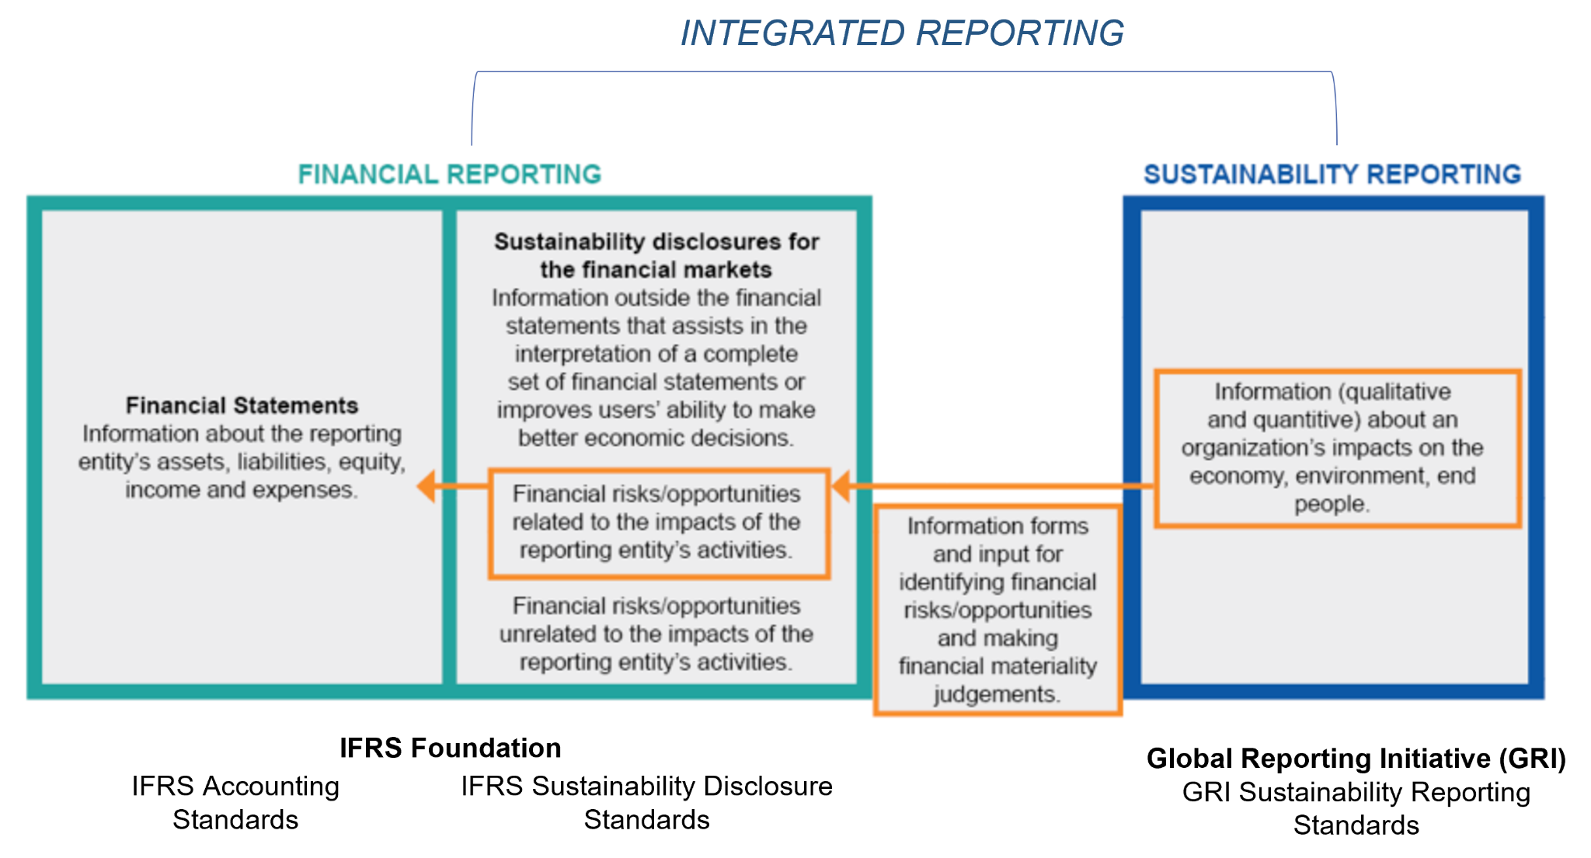

2.3 Additional Resources for Alignment

- IFRS Foundation, IFRS Sustainability Standards Navigator - is where you can find the IFRS Sustainability Standards as well as other supporting guidance documents.
- IFRS Foundation, Compare IFRS S2 Climate-related Disclosures with the TCFD Recommendations - Provides a comparison overview for those transitioning from TCFD to IFRS S2.
- COSO and WBCSD, Applying Enterprise Risk Management to Environmental, Social and Governance-related Risks - guidance designed to help risk management and sustainability practitioners apply enterprise risk management (ERM) concepts and processes to ESG-related risks.
- TCFD, Guidance on Risk Management Integration and Disclosure - provides guidance on the integration of climate risk into a company’s existing Enterprise Risk Management (ERM) systems, as well as on the disclosure of risk management processes.
- UN SSE, SSE Training Tool on Transition Plans - provides an introduction to guidance resources for transition planning and disclosure.

Chapter 3 – Implement
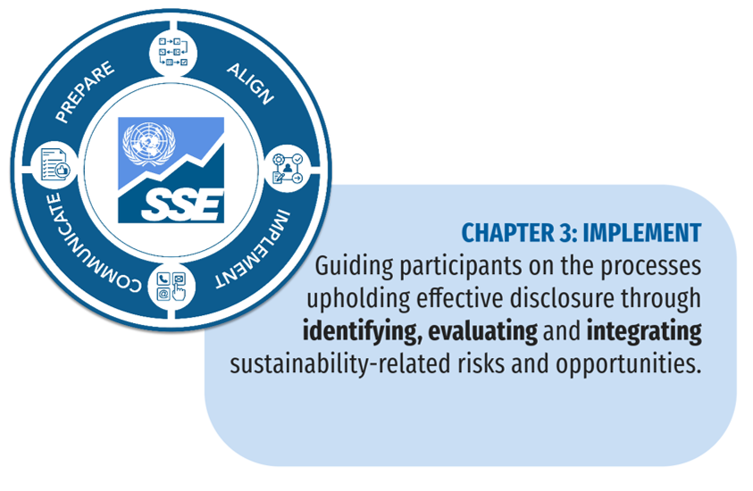
The previous chapter summarized IFRS Sustainability Disclosure Standards requirements on the type of content included in sustainability-related financial disclosures (that is, governance, strategy, risk management and metrics and targets) and the main disclosure concepts a company applies (for example, decision-usefulness). Within the parameters of the content and disclosure requirements, each company makes decisions about what to disclose and how, based on an assessment of how the requirements apply to its unique facts and circumstances. Those decisions depend on the availability and management of information, decision-making procedures and systems and processes for capturing and managing information to be disclosed when applying the IFRS Sustainability Disclosure Standards.
This chapter focuses on some of the main processes or ‘how to’ aspects that support preparation of sustainability-related financial disclosures based on the content elements described in Chapter 2. While the core content elements are common to all companies, the information disclosed will depend on the company’s unique circumstances, operational context, disclosure strategy and risk profile.
This Chapter provides guidance on:
- Identify—identifying sustainability-related risks and opportunities;
- Evaluate—evaluating the materiality of information on sustainability-related risks and opportunities and on using climate scenarios for assessing the resilience of the company’s strategy to climate-related risks; and
- Integrate—considering whether, to what extent and how the identification of sustainability-related risks & opportunities and evaluation processes can be supported by the development of new processes and/or the integration of new considerations into existing processes and systems across the company.
These three processes are separate and distinct, but interrelated. For example, the process of evaluating the materiality of information is dependent upon a company having first identified its sustainability-related risks and opportunities. Although a company can approach the processes in the order set out above, the company can also apply them simultaneously or as a cycle of process development.

3.1 Identify
IFRS S1 requires a company to disclose information about its sustainability-related risks and opportunities. Similarly, IFRS S2 requires a company to disclose information about its climate-related risks and opportunities. This section outlines what the IFRS Sustainability Disclosure Standards say about the sources of those risks and opportunities, the types of sustainability-related risks and opportunities to which the IFRS Sustainability Disclosure Standards apply and how a company identifies those risks and opportunities.
Many factors can give rise to sustainability-related (including climate-related) risks and opportunities. Generally, risks come from interactions between a company and its stakeholders, society, the economy, natural environment and value chain, as described in IFRS S1.2: “Together, the entity and the resources and relationships throughout its value chain form an interdependent system in which the entity operates. The entity’s dependencies on those resources and relationships and its impacts on those resources and relationships give rise to sustainability-related risks and opportunities for the entity.”
The interactions IFRS S1 and S2 refer to can include changes to resources and relationships (see Explainer 3.1) on which the company depends (that is, ’dependencies’) and impacts on those resources and relationships. For example, if extreme weather events affect the quality or availability of raw materials (either manufactured or from nature) on which the business depends, or when the price of those materials increases due to scarcity, the company is at risk from business interruptions or may experience higher costs. The interactions can be direct—for example, as a result of the company’s business model and operations—and indirect—for example, as a result of changes in the external environment in which the company operates.
Appendix B to IFRS 1 explains the relationship between the value that a company creates, preserves or erodes for others and the company’s own ability to succeed and achieve its goals. For example, degradation or depletion of natural resources through the company’s activities or from other sources could cause disruption to the company’s operations with consequential effects for its strategy, business model and financial results. By contrast, regeneration and preservation of resources and investment in staff training and wellbeing could positively affect the company’s strategy, business model, financial results and ability to attract a skilled workforce (IFRS S1.B3).

Helpful Tip 3.1 – Resources and relationships
The IFRS Sustainability Disclosure Standards describe ‘resources and relationships’ as comprising:
- Various forms—resources and relationships can take various forms, including natural, manufactured, intellectual, human, social or financial. These forms equate with the ‘Capitals’ in the Integrated Reporting Framework (IFRS S1.B4).
- Internal or external—resources and relationships can be internal—such as the company’s workforce, its know-how or its organizational processes—or they can be external—such as materials and services the company needs to access or the relationships it has with suppliers, distributors and customers (IFRS S1.B4).
- Balance sheet assets—resources and relationships include those recognized as assets in the company’s financial statements (IFRS S1.B4).
- The value chain—resources and relationships include those throughout the company’s value chain, including supply and distribution channels, the effects of consumption and disposal of the company’s products and the company’s sources of capital and investments (including in associates and joint ventures). Risks to the company’s value chain and business partners can have contagion effects. A company both depends on resources and relationships throughout the value chain and affects those resources and relationships, which contributes to their preservation, regeneration and development, or to their degradation and depletion (IFRS S1.B5).

The type of sustainability-related risks and opportunities to include
IFRS S1 and IFRS S2 require a company to disclose sustainability-related risks and opportunities that could affect the company’s prospects—that is, risks and opportunities that could reasonably be expected to affect the company’s cash flows, access to finance or cost of capital over the short, medium or long term (IFRS S1.3).
Sustainability-related risks and opportunities that could not reasonably be expected to affect a company’s prospects are outside the scope of IFRS S1 (IFRS S1.6) and IFRS S2 (IFRS S2.4). However, some types of information may still influence primary users’ decisions regardless of the magnitude of the potential effects on the future event or the timing of that event—for example, if a particular sustainability-related risk is highly scrutinized by users (IFRS S1.B24). Note that even when sustainability-related risks are outside the scope of IFRS S1 and IFRS S2, a company might be required to disclose those risks in the general purpose financial report or through other channels, such as for compliance purposes or in sustainability disclosures.
A company uses its risk management processes to identify sustainability-related risks and opportunities that could reasonably be expected to affect the company’s prospects. Judgment may be used when identifying sustainability-related risks and opportunities. The judgment used must be disclosed to help users understand the impact of judgment applied (IFRS S1.75 (a)).
In addition, the company:
- Uses the IFRS Sustainability Disclosure Standards where available, including the Standard that specifically applies to the sustainability-related risk or opportunity in question, such as IFRS S2 in the case of climate-related risks (IFRS S1.54 and IFRS S1.56).
- Uses all available reasonable and supportable information (see Explainer 3.2) as at the reporting date, without undue cost and effort (IFRS S1.B6(a)).
- Uses all reasonable and supportable information available at the reporting date to determine the scope of the company’s value chain, including its breadth and composition in relation to each sustainability-related risk and opportunity. The company is required to determine the scope of its value chain because different sources of risks and opportunities arise within the value chain (IFRS S1.B6(b)).
- Refers to and considers the applicability of disclosure topics in the industry-based SASB Standards (IFRS S1.55(a)).
- Applies judgment when determining which sources of guidance to apply IFRS S1.75(b). In the absence of an IFRS Sustainability Disclosure Standard that specifically applies to a sustainability-related risk or opportunity, the company may refer to and consider:
  - the CDSB Framework Application Guidance for Water-related and Biodiversity-related Disclosures (IFRS S1.55(b)(i));
  - recent pronouncements of standard setting-bodies whose requirements are designed to meet the information needs of primary users (IFRS S1.55(b)(ii));
  - the sustainability-related risks and opportunities identified by companies that operate in the same industry(ies) or geographical region(s) (IFRS S1.55(b)(iii)).
- May refer to and consider the applicability of Global Reporting Initiative Standards and European Sustainability Reporting Standards (IFRS S1.C2), provided that:
  - those sources are used to meet the objective of the IFRS Sustainability Disclosure Standards;
  - those sources do not conflict with the IFRS Sustainability Disclosure Standards;
  - the company applies those sources according to the requirements of the Standards. This means that the resulting disclosures are relevant to the decision-making of users of general purpose financial reports and faithfully represent the sustainability-related risk or opportunity concerned;
  - applying those sources does not obscure material information required by the IFRS Sustainability Disclosure Standards.

Helpful Tip 3.2 – Identifying sustainability-related risks and opportunities
In identifying sustainability-related risks and opportunities that could reasonably be expected to affect a company’s prospects, a company shall apply IFRS Sustainability Disclosure Standards. To identify such risks and opportunities, the IFRS Sustainability Disclosure Standards can be used together with other sources of guidance.
SASB Disclosure Topics
When applying IFRS S1 companies are required to consider SASB Disclosure Topics. The SASB Standards are designed to serve as a starting point for companies to identify sustainability-related risks and opportunities. In the SASB Standards, disclosure topics and metrics are organised by industry, enabling a company to identify sustainability-related risks and opportunities that are applicable to its business model and associated activities. A company shall refer to and consider the applicability of the disclosure topics in the SASB Standards. A company might conclude that the disclosure topics are not applicable.
Industry-based guidance
IFRS S2 includes industry-specific guidance (derived from SASB Standards). This guidance covers 68 industries and it suggests possible ways to identify, measure and disclose information about climate-related risks and opportunities. A company is required to consider the applicability of disclosure topics in the industry-based Guidance on Climate Related Disclosures. A company will apply judgment to determine whether the disclosure topics referred to in the guidance are applicable.
Other sources of guidance
A company may- to the extent that these sources do not conflict with IFRS Sustainability Disclosure Standards – refer to and consider the applicability of these other source of guidance to identify sustainability-related risks and opportunities. These may include:
- the CDSB Framework Application Guidance for Water-related Disclosures and the CDSB Framework Application Guidance for Biodiversity-related Disclosures;
- the most recent pronouncements of other standard-setting bodies whose requirements are designed to meet the information needs of users of general purpose financial reports; and
- the sustainability-related risks and opportunities identified by companies that operate in the same industry(s) or geographical region(s).

Tip 3.3 – Reasonable and supportable information
A company uses all available reasonable and supportable information at the reporting date to prepare and disclose sustainability-related financial information, without undue cost or effort, about sustainability-related risks and opportunities that could reasonably affect the company’s prospects.
Reasonable and supportable information (IFRS S1.B8) is information that: is specific to the company; takes account of general conditions in the external environment; includes information about past events, current conditions and forecasts of future conditions; and in some cases, is specified by the Standards.
What kind of data is reasonable and supportable?
A company can use various sources of data (IFRS S1.B9), both internal and external, including but not limited to: risk-management processes; industry and peer group experience; external ratings; and reports and statistics.
It is important to note:
- Information used by a company when preparing its financial statements, operating its business model, setting its strategy and managing its risks and opportunities is considered to be available to the company without undue cost and effort (IFRS S1.B9).
- A company is not required to undertake an exhaustive search for information—primary users’ information needs and the cost and efforts for the company should be balanced (IFRS S1.B10).
- The assessment of what constitutes undue costs and effort can change over time as circumstances change. As much as possible, a company uses consistent data and makes consistent assumptions when preparing sustainability-related financial information and prepares the related financial statements with the corresponding data and assumptions.

3.2 Evaluate
This section considers the definition of ‘materiality’ in the Standards, what is meant by ‘material information’ and the types of evaluations to support the judgment processes in identifying material information. It then provides an introduction to scenario analysis, which helps a business in evaluating its resilience to climate-related risks. Building off the previous section which focuses on identifying material risks and opportunities, this section pertains to the evaluation of those risks and opportunities and the specific information that is considered material according to the IFRS Standards and therefore should be disclosed.

Evaluating materiality
IFRS S1 requires a company to disclose material information about the sustainability-related risks and opportunities that could reasonably be expected to affect its prospects (IFRS S1.17 and IFRS S1.B13) given the company’s own circumstances (IFRS S1.B16).
Determining what information might be material can be broken down into two steps:
- Identifying sustainability-related risks and opportunities that could affect a company’s prospects (see section 3.1); and
- Applying judgment (IFRS S1.75(c)) to identify material information for sustainability-related financial disclosure and testing resilience.
In the context of sustainability-related financial disclosures, information is material if omitting, misstating or obscuring that information could reasonably be expected to influence decisions that primary users of general purpose financial reports make on the basis of those reports (see tip 3.4). These include financial statements and sustainability-related financial disclosures and provide information about a specific reporting entity (IFRS S1.18 and IFRS S1.B13).

Helpful Tip 3.4 – Informing decisions of primary users
Information influences decisions of primary users of general purpose financial reports when it informs their decisions about:
- Providing resources to the company;
- Buying, selling or holding equity and debt instruments;
- Providing or settling loans and other forms of credit; and
- Exercising rights to vote on, or otherwise influence, the company’s management’s actions that affect the use of the company’s economic resources (IFRS S1.B14).
The decisions depend on users’ expectations about returns—for example, dividends, principal and interest payments or market prices (IFRS S1.B15). When assessing whether information could influence the decisions of primary users of general purpose financial reports, management considers the characteristics of the users of information and works on the assumption that they have reasonable knowledge of the business and economic activities and will review and analyze the information diligently (IFRS S1.B16-B17). Primary users of general purpose financial reports may have varying and sometimes conflicting information needs, but IFRS S1 is designed for companies to disclose sustainability-related financial information that meets the common information needs of primary users (IFRS S1.B18).

For the purposes of IFRS S1 and IFRS S2, ‘materiality’ is company-specific, and it is based on the nature or magnitude, or both, of the items to which the information relates, in the context of the company’s sustainability-related financial disclosures (IFRS S1.14). IFRS S2 does not contain any specific requirements or guidance on materiality because the provisions in IFRS S1 apply equally to climate-related disclosures.
The definitions of ‘material’ and ‘material information’ in IFRS S1 align with the International Accounting Standards Board’s definitions in its Conceptual Framework and IAS 1 Presentation. “Material information” in the context of sustainability-related financial disclosures is defined below and in Appendix A of IFRS S1. Using conceptually aligned definitions supports connectivity across a company’s general purpose financial reports prepared in accordance with IFRS Accounting Standards and Sustainability Disclosure Standards (Basis for Conclusions on IFRS S1.BC67).
The IFRS Sustainability Disclosure Standards do not specify any thresholds for materiality or predetermine what might be material in a particular situation. A company is therefore required to make judgments about materiality and material information in the context of sustainability-related disclosures and the objectives of IFRS S1 and IFRS S2. Materiality judgements are specific to the company (IFRS S1.B19). However, the company is required to consider:
- The requirements of the Standards specifically applicable to the sustainability-related risk or opportunity, or in the absence of specifically applicable Standards, the sources listed in the Identify section. (IFRS S1.B20);
- Quantitative and qualitative factors, including, for example, the nature and magnitude of the effects of sustainability-related risks or opportunity on the company (IFRS S1.B21);
- Sustainability-related risks and opportunities judged to be material because they are highly scrutinized by users of general purpose financial reports, even when those risks and opportunities might not affect the company’s cash flows until many years in the future (IFRS S1.B24);
- In addition, a company is required to consider risks and opportunities that are unlikely to occur but have a potentially high impact. The company must consider relationships between the impacts of the company’s activities on the environment and society and the impacts of the environment and society on its cash flows, cost of capital and access to finance (Basis for Conclusions on IFRS S1. BC70(a));
- Changes in assumptions and conditions over time (Basis for Conclusions on IFRS S1.BC70(b));
- Potential changes in the information needs of users of general purpose reports (Basis for Conclusions on IFRS S1. BC70(c)).
When judging whether information about possible future events with uncertain outcomes is material, the company must consider:
- All pertinent facts and circumstances that could affect possible outcomes (IFRS S1.B23).
- The potential effects of the events on the amount, timing and uncertainty of the company’s future cash flows over the short, medium and long term—that is, the possible outcome, the range of possible outcomes and the likelihood of the possible outcomes within that range (IFRS S1.B22).
- Low-probability and high-impact outcomes and possible future events judged to be more likely to occur and with significant potential effects. Low-probability and high-impact outcomes might be material either individually or in combination with information about other such outcomes (IFRS S1.B23).
- The effect of potential risks individually and in aggregate (IFRS S1.B23).
A company reassesses materiality judgements at each reporting date so that management can regularly take account of changes in the company’s circumstances or in the external environment (IFRS S1.B28).
Chapter 4 provides guidance on how to disclose material information, including how a company manages these disclosures alongside disclosure of non-material information when required to meet local legal or regulatory requirements.

Helpful Tip 3.5 – Materiality test
When testing materiality, the following checklist can be used:
Identifying potentially material information
- Does the information affect the company’s prospects, given the company’s own circumstances?
- Is the information material based on the nature or magnitude, or both, of the items to which it relates and in the context of the company’s sustainability-related financial disclosures as a whole?
- Would the information’s omission, misstatement or obscuring reasonably be expected to affect primary users’ decisions and/or compromise their common information needs?
- Have the requirements of the relevant Standards been taken into account?
- Is the information identified in accordance with the relevant Standards—either individually or in combination with other information—material, taking account of quantitative and qualitative factors and in the context of the company’s sustainability-related financial disclosures as a whole?
Making materiality judgements
- Is the information identified either individually or in combination with other information, material in the context of the company’s sustainability-related financial disclosures taken as a whole?
- Have you considered both quantitative and qualitative factors?
- Have you considered the potential effect of future events on amount, timing and uncertainty of the company’s future cash flows over the short, medium and long term?
- Have you considered the range of possible outcomes and the likelihood of the possible outcomes within that range?
Avoiding obscuring material information
- Have you ensured that material information is clear and distinguishable from immaterial information?
- Have you ensured that items of information that are dissimilar are not inappropriately aggregated?
- Have you ensured that items of information that are similar are not inappropriately disaggregated?

Helpful Tip 3.6 – Aggregation and disaggregation
When providing material information, the company will need to make a judgment around both aggregating and disaggregating information (S1.B29). It is important that material information about sustainability-related risks and opportunities is not obscured by immaterial information as a result of aggregating disclosure. The company might need to disaggregate information for example by geographical location or in consideration of the geopolitical environment to ensure clarity for primary users. Information should only be aggregated if it has shared characteristics (S1.B30).

Scenario analysis for testing resilience
IFRS S2 requires a company to use climate-related scenario analysis to assess its resilience to climate-related risks (see Chapter 2). Scenario analysis is a tool to enhance critical strategic thinking and to explore possible paths of development leading to particular outcomes (scenarios). Scenario analysis is intended to explore alternatives that may result in different outcomes, be it positive or negative, in order to identify potential responses by the company to manage these.
Some of the considerations that might inform the development of scenario analysis processes include:
- Using an approach commensurate with the company’s circumstances: A company is permitted to use an approach to climate-related scenario analysis that is commensurate with its circumstances (IFRS S2.22) when the analysis is conducted and each time it is repeated (and, at a minimum, in line with its strategic planning cycle) (IFRS S2.B3). When assessing its circumstances, a company considers:
  - its exposure to climate-related risks and opportunities. Generally, the higher the degree of exposure to climate-related risks, the more quantitative and technically sophisticated the approach to scenario analysis is (IFRS S2.B4).
  - information about how the climate-related risks and opportunities are identified and the processes used to assess, prioritize and monitor climate-related risks and opportunities to inform the company’s assessment of its exposure to climate-related risks (IFRS S2.B5).
  - the skills, capabilities and resources that are available to the company from internal and external sources. The assessment of circumstances should take account of the maturity of climate-related scenario analysis within the company and the industry in which it operates. For example, in industries where climate-related scenario analysis is an established practice, such as extractives and mineral processing industries, a company should have strengthened its skills and capabilities (IFRS S2.B6–IFRS S1.B7).
- Determining an appropriate approach: When a company determines the appropriate approach to climate-scenario analysis, it:
  - takes account of the assessment of circumstances above and the way in which those circumstances might change over time, which in turn will affect the company’s approach to scenario analysis as its skills, capabilities and resources develop (IFRS S2.B3 and IFRS S2.B16).
  - uses all reasonable and supportable information available at the reporting date without undue cost and effort, including information about past events, current conditions and forecasts of future conditions, qualitative and quantitative information, and information obtained from external sources or developed internally (IFRS S2.B9).
  - applies judgment to evaluate inputs and analytical choices. The degree of judgment required depends on the availability of detailed information for the time horizons over which the company conducts the resilience assessment (IFRS S2.B10).
- Selecting inputs to the scenario analysis: A company selects inputs to the scenario analysis, including:
  - which scenario(s) to use—for example, international or regional, publicly available or bespoke, consistent with a range of temperatures and orderly or disorderly transition outcomes. The company may use one or more climate-related scenarios, but must have a reasonable and supportable basis for its choices. For example, a company with operations in jurisdictions where GHG emissions are regulated might determine that it is appropriate to select scenarios consistent with an orderly transition to a lower-carbon economy or with relevant jurisdictional commitments. Similarly, a company with significant exposure to physical climate-related risks might base its analysis on climate-related scenarios that take account of local conditions (IFRS S2.B12).
  - which variables or other inputs should inform the analysis—in particular, those relevant to understanding the resilience of the company’s strategy and business model to climate-related changes, developments and uncertainties and the company’s particular circumstances, including its activities and the geographical location in which they take place (IFRS S2.B13).
  - which analytical choices should be prioritized—for example, qualitative analysis or quantitative modeling (IFRS S2.B14–IFRS S2.B15 & 15).

3.3 Integrate
Sustainability-related financial disclosures depend on a robust system of processes that includes, among other processes, identification of sustainability-related risks and opportunities, evaluation of materiality and material information, choices involved in climate-scenario analysis and other internal considerations. For example, a company’s identification of sustainability-related risks and opportunities is supported by the systems and processes that capture information about the sources of those risks and opportunities—that is, the resources and relationships on which the company’s business model and strategy depends.
Some companies might already have processes for collecting the content described in Chapter 2. For example, a company might have established processes in response to requirements in a jurisdiction that require the disclosure of corporate governance and risk management arrangements. In those cases, the company can complement, supplement and adjust processes and practices used to collect and monitor information to integrate considerations relating to sustainability-related risks and opportunities. In other cases, the company might need to develop new processes and plan for its integration into the company’s suite of processes over time.
Management may consider several topics to decide whether, to what extent, and how existing systems and processes can be adapted or whether the company needs to develop new systems and processes to capture and manage information for sustainability-related financial disclosure:
- Gap analysis—an analysis to check for gaps in existing systems and processes. Companies can use the SSE Gap Analysis Checklist to start this process.
- Suitability—an evaluation of whether existing processes are suitable for identifying sustainability-related risks and opportunities using the requirements in the Identify section.
- Prioritization criteria—an evaluation of whether prioritization criteria are suitable for prioritizing sustainability-related risks and opportunities. In addition to likelihood and impact, other criteria might apply, such as vulnerability, immanence, and speed of onset.
- Controls—an evaluation of the suitability of existing internal risk controls for the mitigation and management of sustainability-related risks within acceptable levels.
- Contributors—an evaluation of which departments have relevant processes and expertise to contribute to sustainability-related financial disclosure.
- Interconnections—an evaluation of whether existing processes take account of sustainability and climate-related risks and opportunities that might arise from interconnections between different internal and external factors.
- Uncertainty—an integration of sustainability-related risks into existing risk management, governance or finance processes. The company adjusts these processes to take account of uncertainties—including where sustainability-related risks might occur and their effects and timescales—and the unique characteristics of sustainability-related risks and opportunities.

Making use of a disclosure strategy
A company can manage processes and systems in various ways. One possibility is to develop a sustainability-related financial disclosure strategy as a stand-alone strategy or as part of a wider disclosure strategy. A disclosure strategy helps a company to take control of its narrative within general purpose financial reports and to limit or balance users’ opinions and conclusions based on a variety of information sources. It does this by supporting collaboration, knowledge-sharing and cross-functional, interdisciplinary team discussions and/or regular meetings with professionals from finance, risk management, controls and planning, investor relations, legal, sustainability and communications departments. Last but not least, it acts as a reference point and audit trail for documenting, explaining and managing the process of preparing disclosures, including where and how a company has made judgements. Developing the strategy can help a company answer several important questions, summarized in figure 3.1.

Figure 3.1 – Questions a disclosure strategy can answer
Source: UN SSE

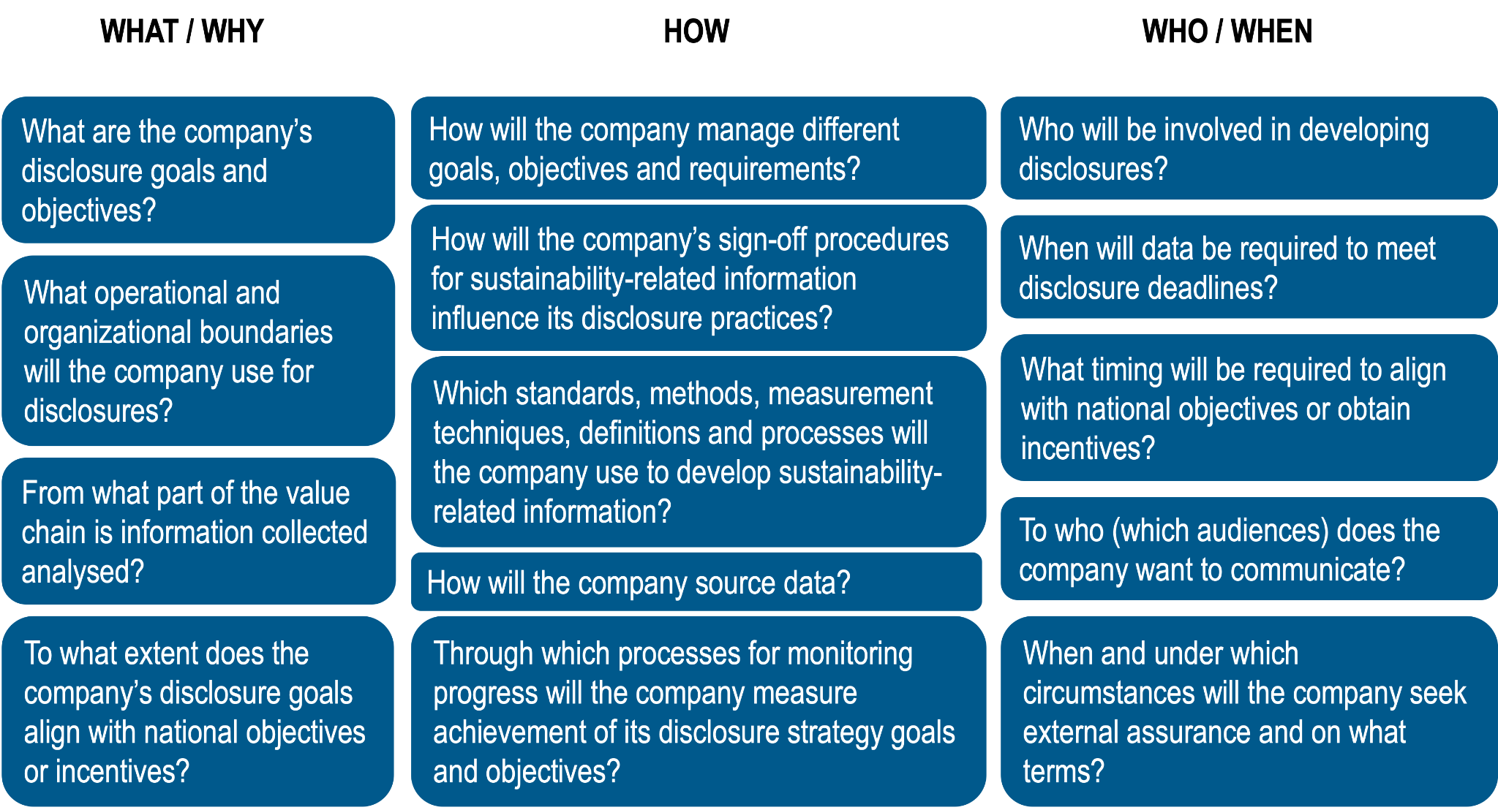

Evaluating ‘what’ and ‘why’
A disclosure strategy can bring clarity to the purpose of sustainability-related disclosures by answering questions such as what are the company’s disclosure goals and objectives? For example, the objectives may include to comply with laws and standards, to communicate management’s strategies or to correspond with peer practice and to contribute to global sustainability goals. These goals will set the boundaries and help companies to also determine the operational boundaries that should be used for disclosure including how far along the value chain information should be collected.
It is important that companies recognize that each organization will have unique circumstances and should clearly identify its reasons for disclosure, re-evaluating on a regular basis. In addition to implementing the Standards, a company might also be required to conform with local listing requirements and might choose to align its disclosures with voluntary sustainability frameworks, local policy objectives and best or common practices among peer or industry groups. As the Standards were developed to build on existing disclosure frameworks and practices, a company that already discloses sustainability-related information might find a high degree of alignment between its existing practices and the requirements of the Standards.
While a listed company should already be aware of the disclosure requirements in its jurisdiction, a company that is not listed might also need to be aware of these requirements. It is therefore also a good idea to communicate expectations to suppliers. A company considering listing should also be aware of local listing requirements and be prepared to provide information if requested for procurement and other value-chain interactions.
When evaluating the ‘what’ and ‘why’ companies may also consider how the company’s disclosure goals reconcile with the national sustainability objectives in the jurisdictions in which it operates? To achieve national environmental or socio-economic objectives, governments in some countries have launched incentives programmes, such as tax cuts or subsidies for aligning business practices with activities that help achieve national sustainability objectives. It is also possible for governments to disincentivize activities that counter national objectives. As such, a company should be aware of national priorities—for example, an understanding of the Nationally Determined Contributions (NDCs) outlining contributions to the Paris Agreement or national frameworks for achieving the 17 Sustainable Development Goals. The company should not only be aware of the sustainability objectives in the jurisdiction where it is headquartered or listed, but other countries where its business activities take place, such as where its main client base is located and where its supply chain is located.

Evaluating ‘how’
Once the end objective or purpose of disclosures (the what and why) are identified, companies should evaluate how they plan to achieve that objective. In doing so, companies can answer questions such as what standards, methods, measurement techniques, definitions and processes will the company use to develop sustainability-related information? In doing so, companies should set out from the start how the company plans to source the data it plans to disclose, and what the company’s sign-off procedures are for sustainability-related information. Questions the disclosure strategy can answer include how will the company source data? Which existing systems and internal controls can the company use or adopt? What new systems and processes does the company need to develop? What is the company’s process for monitoring progress toward achievement of its disclosure strategy goals and objectives?
The disclosure strategy can also identify how the company will evaluate the different methods of disclosure. For example, companies may want to consider what criteria the company will use to evaluate achievement of the objectives and purpose of disclosures, business value, meeting the needs of the intended audience(s), supportable and capable of being clearly communicated?

Evaluating ‘who’ and ‘when’
Intrinsically linked to the how, companies may also wish to identify who will be responsible for the various tasks as well as when those tasks should be completed. Questions that a disclosure strategy can help answer include, who will be involved in developing disclosures, including sustainability-related financial disclosures that achieve those goals? Which departments—for example, risk management, company secretarial, procurement or finance—and which individuals within those departments will be involved? How will the company organize those individuals and departments and what will individual and collective responsibilities be?
A disclosure strategy should clearly identify which audience(s) the company wants to communicate with, and should answer questions such as, what information serves the needs of that audience or those audiences? How will peer group disclosure practices—including those of companies in the same industry group, sector or geographic location—influence the company’s disclosure strategy (if at all)? It can also be useful to identify within the strategy under what circumstances the company will seek external assurance and on what terms.

3.4 Additional Resources for Implementation

- CDP, TCFD Hub, The Use of Scenario Analysis in Disclosure of Climate-related Risks and Opportunities - a high-level introduction to scenario analysis. The TCFD Hub also offers a 1-hour e-learning course on scenario analysis.
- IFC Beyond the Balance Sheet platform – a one-stop shop on sustainability and climate reporting tailored for emerging markets.
- IFRS Foundation, industry-based SASB Standards - provide industry-based metrics on a range of sustainability-related topics that a reporting company must refer to and consider, when applying the IFRS Sustainability Disclosure Standards.
- IFRS Foundation, CDSB Framework Application guidances on water-related disclosures and biodiversity-related disclosures - provides guidance on the disclosure of water- and biodiversity-related financial disclosures that a reporting company may consider using when reporting sustainability-related financial information on these topics.
- UN SSE, Primer on Climate Disclosure Metrics - provides a more detailed overview of and guidance on getting started with climate-related metrics
- WBCSD, Energy Climate Scenario Catalogue - a catalogue of scenarios that businesses can use to conduct strategic climate resilience assessments and explore transition pathways.
- WBCSD, The Reality of Materiality - for companies who wish to understand the different approaches to materiality and how to further develop their internal processes and external disclosure practices

Chapter 4—Communicate
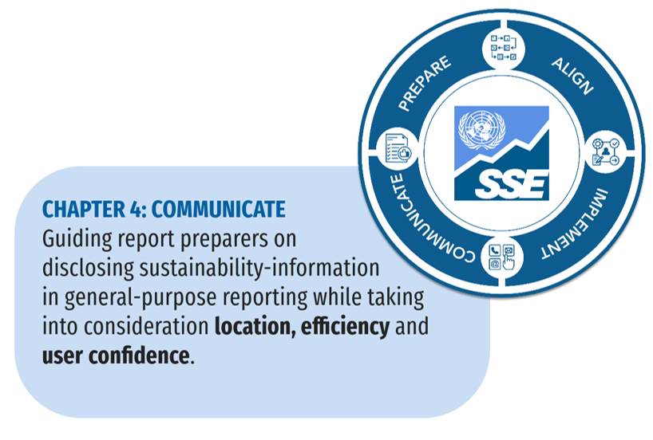
Readers of this Guidance will now be familiar with the reporting landscape (Chapter 1), the requirements in the IFRS Sustainability Disclosure Standards (Chapter 2), and the processes that support the preparation of sustainability-related financial information that those Standards require (Chapter 3). The next step to consider is the subject of this chapter—where and how companies are required to disclose that information. In essence, companies are required to provide sustainability-related financial information that:
- Is decision-useful (IFRS S1.10 and Appendix D);
- Is presented fairly as a complete set of sustainability-related financial disclosures (IFRS S1.11–S1.16);
- Contains material information about the sustainability-related risks and opportunities that could reasonably be expected to affect the company’s prospects (IFRS S1.17–S1.18);
- Depicts the same reporting company depicted in the related financial statements (IFRS S1.20); and
- Presents connections between different types of information (IFRS S1.21–S1.24).
To help report preparers in this endeavor, this Chapter provides guidance on:
- Disclosure location and timing – where sustainability-related financial information should be disclosed, when and for what period
- Effective and efficient communication – how to communicate sustainability-related financial information effectively and how it connects to other information in the same report
- Building confidence – how to maximize confidence in sustainability-related financial information.

4.1 Disclosure location and timing
A company is required to provide sustainability- and climate-related financial information in its general purpose financial report (IFRS S1.60). The structure and contents of general purpose financial reports vary between jurisdictions. In addition to what is required by IFRS Standards, they generally include information that is required by local regulators, such as a company’s financial statements, commentary, discussion and analysis by the company’s management, governance disclosures and communications about strategy. (General purpose financial reports or sections of them might also be known by other terms, such as integrated or strategic reports, annual reports, regulatory filings etc.)
IFRS Sustainability Disclosure Standards do not prescribe the exact placement of different core content areas (governance, strategy, risk management and metrics and targets) within a company’s general purpose financial reports. However, companies typically follow one or a combination of these approaches:
- Integration—In this approach, sustainability-related financial disclosures are integrated into the relevant sections of a company’s general purpose financial statements. For example, a company’s disclosures about the governance of its sustainability-related financial risks and opportunities may be integrated with its overall governance disclosures. This kind of integration might make sense in order to focus the disclosures on whether, to what extent and how the company’s overall processes are applied and adapted to monitor and manage those risks and opportunities. A company following this approach might use navigation tools, such as indexes and symbols that guide users to particular content.
- Autonomous—This approach tends to be followed by companies that include in their general purpose financial reports separate chapters or sections dedicated to particular subjects, such as the environment, the climate and human rights; and also, in relation to other content that is required by local law or by a particular standard-setter or framework-provider.
Whichever approach, or approaches, a company follows, it is required to ensure that the information it discloses is ‘decision-useful’ for its primary users and that the information is provided in accordance with any applicable law, reporting standard or other framework the company has chosen to apply. For example, requiring information to be connected (IFRS S1.21) might necessitate a company to integrate its sustainability-related information with other relevant disclosures; a company might, for instance, be required to integrate information about the oversight of its sustainability-related risks and opportunities with its other governance disclosures.

Materiality and location of disclosure
Chapter 3 (‘Identify’) provides guidance to companies on making materiality judgements and the section on effective communication below explains how a company might distinguish material sustainability-related financial information from other types of information in its general purpose financial reports. Other ways in which a company can ensure that material sustainability-related financial information is clearly identifiable is to use plain language. Companies can also ensure that material information about a particular sustainability-related risk or opportunity is not randomly dispersed among their sustainability-related financial disclosures.
Although a company is required to provide material information in its sustainability-related financial disclosures, the company might also be required to make additional (non-material) disclosures if the material information is insufficient in itself to enable users to understand the effects of sustainability-related risks and opportunities on the company’s cash flows, its access to finance and the cost of capital over the short, medium and long term (IFRS S1.15(b) and B26). Additional information might, for instance, be required in order to explain the context within which sustainability-related risks and opportunities arise, or to enable the material information to be understandable. A company required to provide such additional information is also required to distinguish it from the material information to which it relates (IFRS S1.B27(a)).

Cross-referencing
In order to keep general purpose financial reports as succinct as possible, the disclosure of information that a company is required to make in accordance with an IFRS Sustainability Disclosure Standard may be made by means of a cross-reference to another report published by the company (IFRS S1.63). Disclosure by cross-reference is, however, subject to the following provisos:
- The cross-referenced information is available on the same terms and at the same time as the other sustainability-related financial disclosures (IFRS S1.B45(a));
- The complete set of sustainability-related financial disclosures is not made less understandable by such cross-referencing (IFRS S1.B45(b));
- The information included by cross-reference is otherwise in accordance with IFRS Sustainability Disclosure Standards (for instance, it is relevant, representationally faithful, comparable, verifiable, timely and understandable) (IFRS S1.B46);
- The person or people signing off the general purpose financial reports takes the same responsibility for the information included by cross-reference as they do for the information included directly (IFRS S1.B46); and
- The sustainability-related financial disclosures clearly identify the report and the precise part of the report within which cross-referenced information is located and explain how it can be accessed (IFRS S1.B47).

Timing
A company is required to provide sustainability-related financial information simultaneously with the provision of its related financial statements, and for the same period (IFRS S1.64). Normally, a company is required to make its sustainability-related financial disclosures for a period of 12 months or 52 weeks (IFRS S1.65). A company is also required to identify the financial statements to which its sustainability-related financial disclosures relate (IFRS S1.22).

Change of reporting period
Special requirements apply if a change in a company’s reporting period results in its sustainability-related financial disclosures being reported for a period longer or shorter than twelve months. Companies are required to explain the reasons for any occurrence of this kind (IFRS S1.66).

Discovery of new information
When a company discovers new information after its reporting date, but before the date on which its sustainability-related financial disclosures are authorized for issue, the company is required to update its disclosures if the new information is about conditions that existed at the end of the reporting period (IFRS S1.67, see figure 4.1). And if the new information relates to conditions that occurred after the end of the reporting period, but before the report release date, a company is required to update the original information if the new information could reasonably be expected to influence the decisions made by primary users of the company’s general purpose financial reports (IFRS S1.68).

Figure 4.1 – Dealing with the discovery of new information before report publication
Source: UN SSE

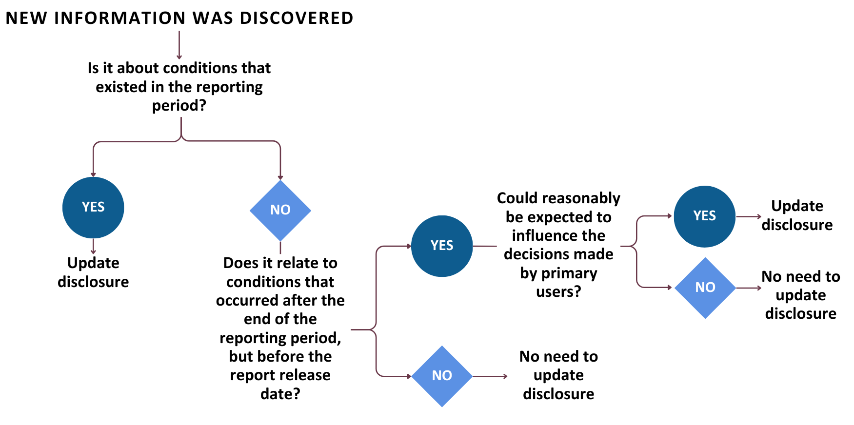

Interim reporting
IFRS Sustainability Disclosure Standards do not require interim reporting. However, when a company is otherwise required—perhaps by local law or its regulators—to make interim reports—it may need to decide how much sustainability-related financial information to provide in them. The required information may, for instance, include an update on the latest complete set of the company’s annual information; or it might require a focus on new information, events and circumstances to avoid duplicating the company’s annual report. Or the information might consist of a complete set of the company’s sustainability-related financial disclosures (IFRS S1.69 and B48).

4.2 Effective and efficient communication
This section sets out how a company might disclose its material sustainability-related financial information so that, in accordance with the requirements in IFRS Sustainability Disclosure Standards, that information is clear, distinguishable from other information, connected, comparable over time and succinct.

Connected information
IFRS S1 requires companies to provide connected information. In particular, companies are required to provide information in such a way that users of their general purpose financial reports can understand:
- The connections between the items to which the information relates, including the different types of sustainability-related risks and opportunities that could reasonably be expected to affect a company’s prospects (IFRS S1.21(a)). For example:
  - the connection between strategy and financial performance resulting in the successful pursuit of a sustainability-related opportunity and in increased revenue (IFRS S1.B40(a));
  - the trade-offs between strategic decisions and sustainability-related risks (IFRS S1.B40(b)), including how a company’s management has evaluated different options when setting its strategies and considering their implications (IFRS S1.B44(b));
  - the connection between sustainability-related targets and financial results, including where a company’s financial position is not affected because the applicable recognition criteria have not been met (IFRS S1.B40(c));
  - the effects of supply-chain management on the availability, quality and price of a company’s resources, and therefore on its sustainability-related risks relating to business inputs (IFRS S1.B43); and
  - how changes in demand and consumer preferences affects a company’s product development and its other strategic responses, such as changes in its facilities and workforce (IFRS S1.B44(a)),
- The connections between the different core content areas on governance, strategy and risk management and between narrative information and quantitative information in a company’s metrics, targets and financial statements (IFRS S1.B41(a)).
- The connections across a company’s sustainability-related financial disclosures and its other general purpose financial reports more generally (IFRS S1.21(b)(ii)).
- The connections between a company’s sustainability-related financial disclosures and its financial statements, which must be identified (IFRS S1.22).
In order to strengthen the connections between the various pieces of information that a company is required to provide:
- The data and currency that the company used, and the assumptions that it made, in preparing its sustainability-related financial disclosures should be consistent, as far as possible, with corresponding data and assumptions that it used to prepare its related financial statements (IFRS S1.23); and any significant differences between them are required to be disclosed and explained (IFRS S1.B42(c)).
- Connections between a company’s disclosures are required to be explained clearly and concisely (IFRS S1.B42(a)).
- A company is required to avoid the unnecessary duplication of information (IFRS S1.B42(b)).

Aggregation and disaggregation
Material information about a company’s particular sustainability-related risk or opportunity is, of course, easier to comprehend when that information is not scattered throughout the company’s general purpose financial reports (IFRS S1.B27(c)). Therefore, items of information are required to be appropriately aggregated, particularly when those items share characteristics (IFRS S1.B30). A company is required to base its decisions on whether and, if so, how to aggregate information, and the extent to which it should do so, on all the relevant facts and circumstances. However, aggregation should not reduce understandability or obscure material information (IFRS S1.B29).
In contrast, the disaggregation of information might be useful to show, for example, a breakdown of a company’s sustainability-related risks and opportunities by geographical location; or to distinguish an area with few resources from one that is abundant in them (IFRS S1.B30).

Avoiding duplication
Although a company is required, in the interests of understandability, to ensure that disparate pieces of information are connected, that requirement does not permit or require the unnecessary duplication of information. For example, assuming that oversight of sustainability-related risks and opportunities has been integrated into a company’s governance arrangements, when governance disclosures have already been made in the company’s general purpose financial reports, the company may cross-refer to related information in those governance disclosures. (IFRS S1.B42(b) and IFRS S2.7).

Comparative information and changes in metrics
Except where transitional reliefs apply, IFRS S1.70 requires a company to disclose comparative information for the preceding period alongside the information it disclosed in relation to its current reporting period. Comparative information includes quantitative information—such as metrics, targets and the financial effects of sustainability-related financial information—in addition to narrative information, when the inclusion of quantitative information would be useful. Comparative information, where details of the same type of metric (GHG emissions, for example) are disclosed alongside each other for the preceding and current year, allows users of information to compare a company’s year-on-year progress and to identify, for example, apparent trends in its performance.

Reporting with other information in general purpose financial reports
General purpose financial reports contain a variety of information other than sustainability-related financial disclosures. For example, a company’s general purpose financial reports might include information:
- To satisfy a range of compliance requirements,
- To reflect the reporting objectives of its management, and
- To conform with the practice of its peers.
When a company provides information in general purpose financial reports to satisfy a range of objectives, it should:
- Ensure that its material sustainability-related financial information is not obscured by other information: When a variety of information is included in a company’s general purpose financial reports, the company is required to avoid obscuring material information (IFRS 1.62). A company might, for example, ensure that its sustainability-related financial information is sufficiently distinguishable from other information. The company could, for instance, use digital tagging to make the material information more prominent; or its sustainability-related financial disclosures could be distinguished from other types of information by the use of formatting such as boxes or shading (IFRS S1.BC74).
- Ensure that its material sustainability-related financial information is clear and understandable. In particular:
  - items of information that are similar or share characteristics should be appropriately aggregated and presented together, provided that in doing so the company does not obscure material information (IFRS S1.B27, B29 and B30).
  - items of information that are dissimilar should be distinguished and disaggregated, especially if that enhances their understandability. For example, a company might be required to disaggregate information and present it by reference to separate geographical locations; or in order to, say, distinguish between water that has been withdrawn from abundant areas and water withdrawn from stressed areas (IFRS S1.B27, B29 and B30).
Table 4.1 illustrates how a company might disclose sustainability-related information in its general purpose financial reports in accordance both with IFRS Sustainability Disclosure Standards and local laws and regulations (IFRS S1.60-61).

Table 4.1 – Deciding on disclosure of material and non-material information in the context of local laws and regulations
Source: UN SSE
Question | Answer
When to include non-material information? | Always, if required by local laws and regulations.  Therefore, include the sustainability-related information that is required by IFRS Sustainability Disclosure Standards to meet local or regulatory requirements, even if that information is not material according to the ISSB’s definition of materiality.  But do not obscure material sustainability-related financial information.
When to include material sustainability-related financial information? | Subject to C below, always include material sustainability-related information, even if not required to do so by local laws and regulations.  Therefore, include material sustainability-related financial information (according to the ISSB’s definition of materiality) in all cases.  Disclose even if local laws and regulations permit a company not to disclose all or some of the information.
When do omit material sustainability-related financial information? | Only when local laws and regulations prohibit the company from disclosing that information.  But, in this case, the company is required to identify the type of sustainability-related financial information not disclosed and explain the source of the restriction.

4.3 Building confidence
This section provides guidance on how to build confidence in the accuracy and reliability of the reported information, be that by being more transparent about uncertainties, errors and omissions, declaring conformance with the IFRS Sustainability Disclosure Standards, or by having the information assured.

Dealing with uncertainty and correcting prior period errors
A company may make estimates and assumptions when measurement uncertainty arises and/or when direct measurement is not possible. However, companies are required to identify any disclosed amounts that were subject to a high level of measurement uncertainty; in doing so, companies are required to disclose the sources of any measurement uncertainty, and the assumptions and judgements that they made when estimating or measuring such amounts (IFRS S1.78).

Using reasonable estimates
Companies can use reasonable estimates when preparing sustainability-related financial disclosures (IFRS S1.79). However:
- Sustainability-related financial information is required to be accurate and provided in such a way that enhances its verifiability (IFRS S1.D23). That requirement does not mean that the information must be perfectly precise in all respects (IFRS S1.D15); indeed, IFRS Sustainability Disclosure Standards explicitly state that a company’s management will have to make judgments when preparing information (IFRS S1.74).
- Reasonable estimates are required to be based on information of sufficient quality and quantity (IFRS S1.D15(e)). Estimates are, of course, approximations that might need to be revised as additional information becomes known (IFRS S1.85).
- Judgements about the future are likely to be particularly uncertain, but the information about the future must reflect both the judgements made by a company and the information on which they are based (IFRS S1.D15(f)).
- Measurements can give rise to uncertainty, not least when a company attempts to provide information about the future effects of its sustainability-related risks and opportunities, or when there are few (if any) measurement techniques available in relation to certain effects of those sustainability-related risks and opportunities, or when the quality or availability of data from a company’s value chain is limited. Reasonable estimates can be used where there is measurement uncertainty too (IFRS S1.78). Secondary data for Scope 3 GHG emissions measurement is an example of an instance in which companies may use reasonable estimates and third-party or industry average data (IFRS S2.B49).
When a company makes estimates, approximations and forecasts, they are required to be clearly identified as such (IFRS S1.D15(c)). And the process for selecting and applying estimates must be free from material error and accompanied by information about the inputs and methods of calculation that the company used to produce those estimates, approximations or forecasts (IFRS S1.D15).
In the case of measurement uncertainty, a company is required (IFRS S1.81) to disclose:
- The nature of the assumption or other source of measurement uncertainty;
- Details around how sensitivity of information influenced disclosure of the methods, assumptions and estimates underlying its calculation, including the reasons for the sensitivity; and
- The expected resolution of an uncertainty and the range of reasonably possible outcomes for the disclosed amount.
A company is also required to disclose an explanation of changes made to past assumptions concerning the disclosed amount if the uncertainty remains unresolved (IFRS S1.81(d)).

Providing comparative information about estimated metrics
When the metrics reported by a company about a preceding reporting period were estimated and relevant new information becomes available in relation to that period, the company is required to disclose a revised comparative amount that reflects the new information (see figure 4.2). In addition, a company is required to disclose the difference between the original and revised amount, together with its reasons for revising the comparative amount (IFRS S1.B50). A company is not required to discuss a revised comparative amount if it would be impracticable to do so, or if the metric is forward-looking (IFRS S1.B51 and B54).

Figure 4.2 – Providing comparative information about redefined or replacement metrics
Source: UN SSE
Note: If practicable, companies are required to disclose a comparative amount for a new metric (IFRS S1.B53 and B.54).

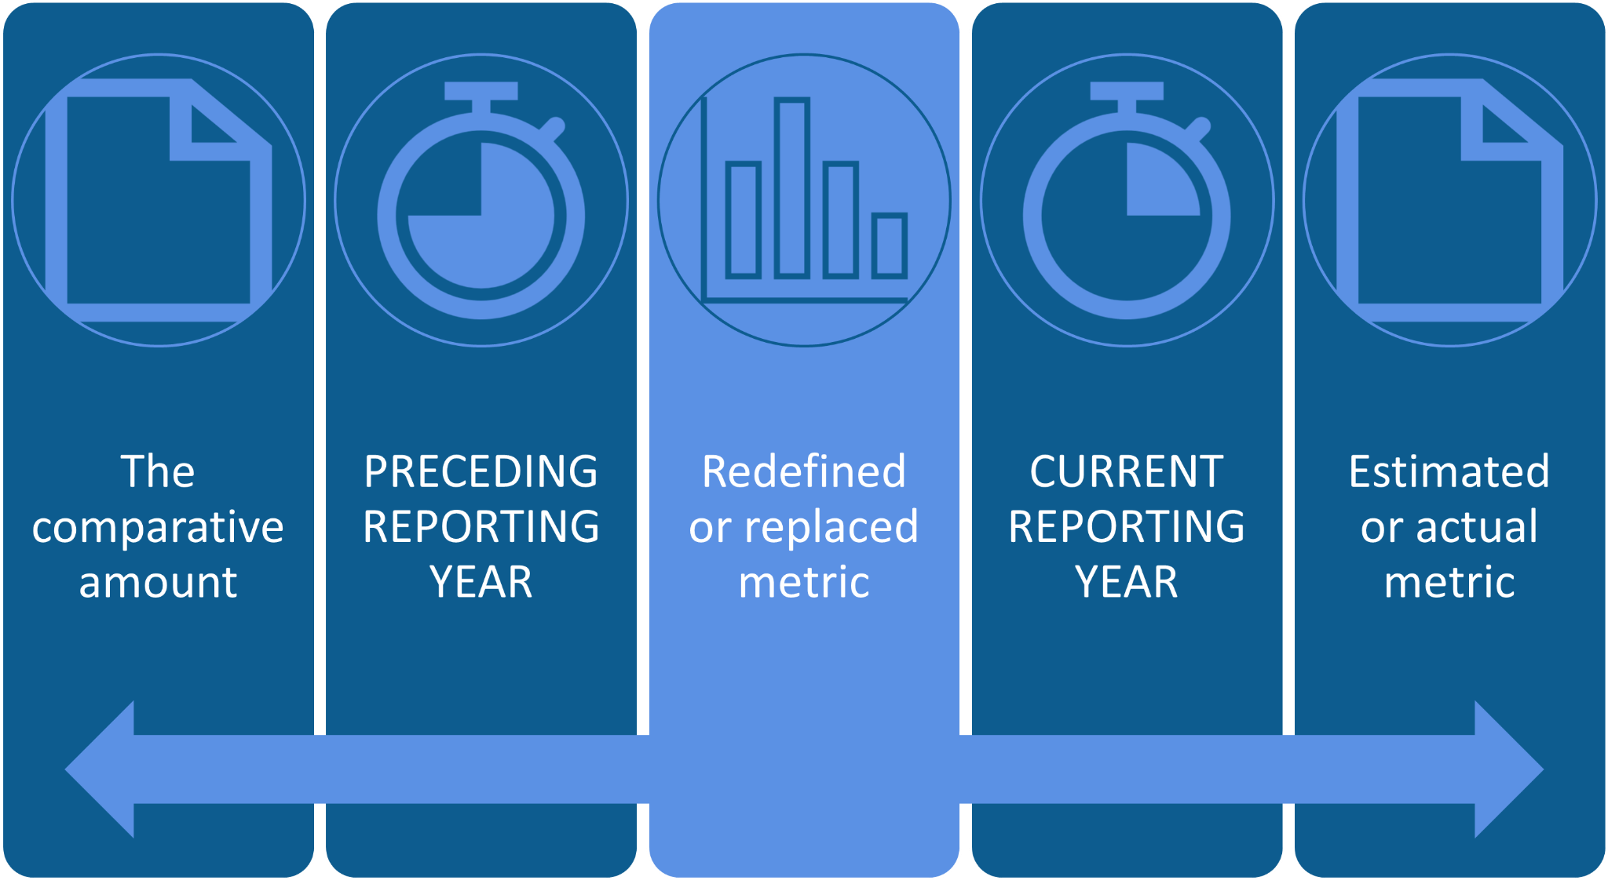

Similarly, when a company redefines or replaces a metric in disclosures that relate to its current reporting period, it is required to disclose a revised comparative amount, unless it would be impracticable to do so. The company is also required to explain the changes and the reasons for redefining or replacing the metric, including why the redefinition or replacement provides more useful information (IFRS S1.B52 and B54).

Commercially sensitive information
Companies are not required to disclose commercially sensitive information (IFRS S1.B34-B37) provided that:
- The information is not already publicly available;
- Disclosure of the information could reasonably be expected seriously to prejudice the economic benefits that a company would otherwise be able to realize in pursuing an opportunity to which the information relates;
- There is no other way of disclosing the information to limit or remove that risk;
- The company discloses the fact that it has used the exemption for commercially sensitive information; and
- The company reassesses at each reporting date whether the information still qualifies for exemption.

Statement of compliance
Companies are required to make an explicit and unreserved statement of compliance when they have complied with all of the requirements of IFRS Sustainability Disclosure Standards. Making such a statement does not prevent a company from omitting to disclose commercially sensitive information and information that is prohibited from disclosure by applicable local laws and regulations. A company is not permitted to make a statement of conformance unless these conditions are satisfied (IFRS S1.72–IFRS S1.73).

Assurance
IFRS Sustainability Disclosure Standards do not require sustainability-related financial information to be assured by third parties. However, in order to build confidence and quality, information disclosed in external reports should follow internal assurance procedures to ensure the data is accurate, appropriate, and reliable. Companies may consider engaging external consultants to undertake assurance procedures to improve the credibility of their data with third party audit and external support may be required initially if the capacity does not exist internally.
As sustainability-related disclosures become more common and are included in mainstream financial filings, the governance process should be similar to those used for existing public financial disclosures and should therefore include a review by the chief financial officer and audit committee or equivalents. An internal assurance process can ensure accurate and better data, leading to better decision-making by the company. The company’s existing internal audit, risk and data control verification systems already developed for mainstream financial reporting can be used for internal audit of sustainability-related financial information. As part of its reporting strategy (see Chapter 3), companies may conduct gap analyses to determine whether to develop internal audit processes for this purpose.
In addition to internal assurance procedures, an external audit can add trust, credibility and recognition to the organization’s reporting practices. Accounting, engineering and specialist service firms are the most common third-party assurance providers. In order to decide the type and level of assurance, it is important for companies to consider standards for assurance within their sector, as well as stakeholder expectations and jurisdictional regulations.

4.4 Additional Resources for Communication
- International Auditing and Assurance Standards Board (IAASB), Understanding International Standard On Sustainability Assurance 5000 - an assurance standard for sustainability reporting.
- IFC Beyond the Balance Sheet platform – a one-stop shop on sustainability and climate reporting tailored for emerging markets.
- IFRS Foundation, Integrated Reporting Framework - promotes a more cohesive and efficient approach to corporate reporting and communicates the full range of factors that materially affect the ability of an organisation to create value over time.
- WBCSD, Delivering impact in a time of complexity -> reporting matters 2023 - the annual review of WBCSD’s member companies’ sustainability and integrated reports shows the evolution of disclosures and guides companies on communicating sustainability-related information.

www.ifrs.org/knowledgehub
IFRS Foundation announces International Sustainability Standards Board, consolidation with CDSB and VRF, and publication of prototype disclosure requirements,
IFRS Sustainability Disclosure Standards endorsed by international securities regulators
IFRS Sustainability Knowledge Hub: www.ifrs.org/knowledgehub
IFRS Sustainability Knowledge Hub, http://www.ifrs.org/knowledgehub
Find out more about the UN Sustainable Development Goals at www.sdgs.un.org/goals
Find out more about the Paris Agreement at www.unfccc.int/process-and-meetings/the-paris-agreement
UN Convention on Biological Diversity: www.cbd.int
Consultation paper and comment letters: Sustainability Reporting, https://www.ifrs.org/projects/completed-projects/2021/sustainability-reporting/consultation-paper-and-comment-letters/
Sustainable investor relations guidance: Targeting investors and analysts, https://www.wbcsd.org/Overview/CFO-Network/Resources/Sustainable-investor-relations-guidance-Targeting-investors-and-analysts
GRESB Assessments, https://www.gresb.com/nl-en/gresb-assessments/
For example, companies may report on their participation in industry bodies such as ICCM for mining and metals or IPIECA for oil and gas.
For example, companies may report on their participation in initiatives such as the UN SSE initiative, the Mission Possible Initiative, or other initiatives.
McKinsey Sustainability, Does ESG really matter—and why?
A comprehensive list of ESG policies and reporting initiatives can additionally be found here - The Reporting exchange - ESG Book.
For more information see: ESG – a brief history of its development – Part 2 – CarbonView and The Rise of Standardized ESG Disclosure Frameworks in the United States (harvard.edu).
The Better Alignment Project is a part of the Corporate Reporting Dialogue.
World Business Council for Sustainable Development (WBCSD), ESG Disclosure Handbook
IFRS - Who uses IFRS Accounting Standards?
IFRS Foundation—Our structure
Summarized from IFRS website “About the International Sustainability Standards Board”
IFRS Sustainability Disclosure Standards’ characteristics of decision-useful information are described later in this chapter. For an introduction to the meaning of the term in the context of climate-related disclosure, see CDSB
The GRI Standards offer a set of global, modular standards for reporting on sustainability impacts
IFRS S1 General Requirements for Disclosure of Sustainability-related Financial Information
IFRS S2 Climate-related Disclosures
IFRS - Request for Information and comment letters: Consultation on Agenda Priorities
IFRS Sustainability Disclosure Taxonomy
Learn more about NDCs on this UNFCCC webpage
See IFRS S1.B3 for examples of dependencies and impacts that could give rise to sustainability-related risks and opportunities.
COSO’s “Enterprise Risk Management – Applying Enterprise Risk Management to Environmental, Social and Governance Risks” and WBCSD and the World Economic Forum’s annual Global Risk Report are additional resources that can help to inform the identification of sustainability-related risks and opportunities.
CDSB Framework Application guidance for water-related disclosures
CDSB Framework Application guidance for biodiversity-related disclosures
Among other resources, companies can consult the IFRS Foundation Practice Statement 2—Making Materiality Judgements and the WBCSD’s ESG Disclosure Handbook
The Model Guidance draws on considerations from IFRS Sustainability Disclosure Standards. The development of climate scenario analysis might also be informed by resources on the TCFD Hub, the GESI-CDP Scenario Analysis Toolkit, WBCSD’s Energy Climate Scenario Catalogue and WBCSD’s Climate Scenario Analysis and Application Guide for Food, Agriculture and Forest Products
The TCFD’s Guidance on Risk Management Integration and Disclosure (October 2020) provides guidance on how existing risk management processes can be developed to take account of climate-related risks
COSO “Achieving Effective Internal Control over Sustainability Reporting” provides supplemental guidance on implementing controls and governance processes over the collection, review, and reporting of sustainability information using the globally recognized COSO Internal Control-Integrated Framework
WBCSD’s ESG Disclosure Handbook goes through the ESG disclosure judgment process and comprises three process steps (evaluate, decide, document), as well as six key questions.
For example, IFRS - European Commission, EFRAG and ISSB confirm high degree of climate-disclosure alignment
Learn more about NDCs on this UNFCCC webpage
For example, IAASB - Understanding International Standard On Sustainability Assurance 5000

